BENGALURU NORTH UNIVERSITY
(2023-2024)



A Project Report on

“BlockFerns Reality”

(A Real-Estate Management System)
Submitted in partial fulfillment of the requirement for award
Of

BACHELOR OF COMPUTER APPLICATION

BY

Mohammed Afreed Pasha

(U19NQ21S0028)

Under the guidance of
Mrs. Meera Satish
Asst. Professor
Department of Computer science
Cambridge College
Bangalore-560036


DEPARTMENT OF BACHELOR OF COMPUTER APPLICATION

CAMBRIDGE COLLEGE

K R Puram, Bengaluru, Karnataka 560036
(2023-2024)

CERTIFICATE

This is to certify that Mohammed Afreed Pasha (U19NQ21S0028) of VI SEM BCA has carried out the project titled ‘BlockFerns Reality’ (A Real-Estate Management system project) under the guidance of Mrs. Meera Satish and submitted in partial fulfilment of Bachelor of Computer Applications for the academic year 2023-2024.

Head of Department Principal

Head of Department External Signature

DECLARATION

I Mohammed Afreed Pasha hereby declare that the project work titled ‘BlockFerns Reality’ (A Real-Estate Management system project) is a Bonafide work carried out by me under the guidance of “Mrs. Meera Satish” Assistant Professor, Dept. of BCA.

Mohammed Afreed Pasha

(U19NQ21S0028)

ACKNOWLEDGEMENT

I would like to express my sincere thanks to our institution CAMBRIDGE COLLEGE, for providing excellent infrastructure for the completion of the project.
I wish to express my wholehearted thanks to my principal Dr ASHWINI K, for her kind support in carrying out this project.
I would like to extend hearty thanks to my HOD, Mrs MEERA SATISH for her valuable suggestions, guidance and support in the completion of the project.
I would like to thank all teaching and non-teaching staff who are directly and indirectly supported in carrying out this project successfully. I extend my heartfelt thanks to my parents, friends for their mutual support provided in completion of the project

Mohammed Afreed Pasha

(U19NQ21S0028)

TABLE OF CONTENTS

SL NO | SUBJECT | Page No.
01 | ABSTRACT | 6
02 | INTRODUCTION | 7
03 | Problem Statement | 8
04 | GOAL AND OBJECTIVES | 8
05 | FEASIBILITY STUDY | 9
06 | SYSTEM ENVIRONMENT  ● Hardware Configuration  ● Software Configuration | 9-10
07 | SOFTWARE FEATURES  ●HTML  ●PHP  ● JavaScript  ● BOOTSTARP  ●SQL database | 10-11
08 | SYSTEM DESIGN  ● ER Diagram  ● Use Case Diagram  ● Admin Use Case Diagram  ● Data Flow Diagram | 12-18
09 | CODING | 19-76
10 | TESTING | 77-79
11 | OUTPUT | 80-83
12 | FUTURE ENHANCEMENT | 84
13 | CONCLUSION | 85
14 | BIBLIOGRAPHY | 86

ABSTRACT
The Real Estate Management System is a comprehensive PHP project designed to facilitate the efficient management of real estate properties. This system provides a platform for users to manage various aspects of real estate, including property listings, client interactions, and administrative tasks.

Key features of the system include:
- Property Management: Users can add, update, and delete property listings. Each listing includes details such as location, price, size, and additional features.
- User Management: The system supports multiple user roles, including administrators, agents, and clients. Each role has specific permissions to ensure secure and efficient management.
- Booking and Inquiries: Clients can make inquiries and book property visits directly through the platform, streamlining the interaction between clients and agents.
- Admin Dashboard: A centralized dashboard allows administrators to monitor all activities, manage users, and oversee property listings.
- Search and Filter: Advanced search and filtering options help users quickly find properties that match their criteria.

In particular, this Real Estate Management System Project in PHP focuses mainly on publishing and viewing properties. To be more precise, the system helps to keep a number of sales and rental properties. Also, the system contains all the buyers, sellers, and agent information. In addition, the system allows adding up the builder’s account too. Evidently, this project contains an admin panel and a simple client-side. In an overview of this web application, the user can simply register in order to use the features. Here, clients can search for the property details using the state names. As a result, the system filters out all the available properties with detailed information. The user can view property details such as name, location, pricing, features, images, floor plans, and more. In fact, this simple real estate project in PHP exposes the property details to the buyers with the contact information of the sellers.

INTRODUCTION

The real estate industry is one of the fastest-growing industries in the world. With the increasing demand for housing and commercial spaces, the need for an efficient and effective real estate management system has become more pressing than ever. The Real Estate Management System Project in PHP is designed to provide a comprehensive solution for the real estate industry.

The system is designed to provide a platform for users to search for properties based on various criteria such as location, price, and property type. The system also allows users to submit their properties for sale or rental purposes, and provides an instalment calculator to help users determine their monthly payments. Additionally, the system features a testimonial section where users can share their experiences with the system.

The system's admin panel provides full control over the system, allowing administrators to manage users, states, cities, properties, and feedback. The system is designed to be user-friendly, with a simple and clean dashboard that provides an excellent user experience.

The Real Estate Management System Project in PHP is an ideal solution for real estate agents, property owners, and buyers. The system provides a comprehensive platform for buying and selling properties, and its features are essential for a real estate management system. The system's admin panel provides full control over the system, making it easy to manage and maintain.

The objectives of the Real Estate Management System Project in PHP are:

To provide a comprehensive platform for buying and selling properties
To provide an efficient and effective way of managing properties
To provide a user-friendly interface for users to search for properties
To provide an instalment calculator to help users determine their monthly payments
To provide a testimonial section where users can share their experiences with the system
The scope of the Real Estate Management System Project in PHP includes:

Property searching and submitting
Instalment calculator
Testimonial section
Admin panel for managing users, states, cities, properties, and feedback
The Real Estate Management System Project in PHP is a comprehensive solution for the real estate industry, and its features are essential for a real estate management system. The system's admin panel provides full control over the system, making it easy to manage and maintain.

Problem Statement

The real estate industry is growing rapidly, and the traditional methods of buying, selling, and renting properties are becoming increasingly inefficient. The current system lacks a centralized platform for property owners, buyers, and renters to interact and conduct transactions. This leads to several problems, including:

Inefficient Property Search: Property seekers have to rely on physical visits to properties, newspaper advertisements, or word of mouth to find suitable properties, which is time-consuming and often yields limited results.
Lack of Transparency: Property owners and agents often withhold information about properties, making it difficult for buyers and renters to make informed decisions.
Insecure Transactions: The lack of a secure online platform for transactions increases the risk of fraud and miscommunication between parties.
Inefficient Property Management: Property owners and managers struggle to keep track of property listings, bookings, and maintenance requests, leading to delays and inefficiencies.
Limited Feedback Mechanism: There is no effective way for buyers, renters, and property owners to provide feedback about their experiences, making it difficult to improve the overall quality of services.

Goal

The goal of this project is to design and develop a Real Estate Management System that provides a centralized platform for property owners, buyers, and renters to interact and conduct transactions efficiently and securely. The system should enable users to search for properties, submit property listings, manage bookings and maintenance requests, and provide feedback about their experiences.

Objectives

To design a user-friendly interface for property seekers to search for properties based on various criteria.
To develop a secure online platform for property owners to submit property listings and manage bookings and maintenance requests.
To implement a feedback mechanism for users to rate and review properties and services.
To provide a centralized dashboard for property owners and managers to track property listings, bookings, and maintenance requests.
To ensure the security and integrity of user data and transactions.

Success Metrics

Increase in the number of property listings and searches on the platform.
Improvement in user satisfaction ratings based on feedback and reviews.
Reduction in the time taken to complete transactions and respond to user queries.
Increase in the number of successful bookings and rentals.
Improvement in the overall quality of services provided by property owners and managers.

FEASIBILITY STUDY

The feasibility of the Real Estate Management System Project in PHP is high. The system is designed to be scalable and can handle a large number of users and properties. The system's use of PHP and MySQL ensures that it is reliable and can handle a high volume of traffic. The system's features are essential for a real estate management system, and the system's admin panel provides full control over the system, making it easy to manage and maintain.

Technical Feasibility: The system is built using PHP and MySQL, which are widely used and well-established technologies. The system's architecture is designed to be modular, making it easy to maintain and update.

Operational Feasibility: The system is designed to be user-friendly, with a simple and clean dashboard that provides an excellent user experience. The system's features are easy to use, and the system's admin panel provides full control over the system, making it easy to manage and maintain.

Economic Feasibility: The system is designed to be cost-effective, with a low cost of development and maintenance. The system's features are essential for a real estate management system, and the system's admin panel provides full control over the system, making it easy to manage and maintain.

SYSTEM ENVIRONMENT
This topic gives information about the hardware and software specification used for developing this project.
In order to run this project, the system must contain the following software and hardware requirements. All the details are minimum configuration. The system may contain higher capabilities than the requirement mentioned below.
Hardware Configuration
1. 32/64 bit operating system
2. 4 GB RAM or above
3. 1024*768 Resolution monitor
4. 40 GB hard disk or above
5. Keyboard

Software Configuration
1. Operating System- Windows 10
2. Languages: PHP, HTML, JavaScript, CSS(Bootstrap)
3. Database: MySQL
4. Browser: Chrome etc
Documentation Software
1. Word Processor - Microsoft Word
2. Operating System – Windows 10

SOFTWARE FEATURES

FRONTEND DESIGN
      - HTML: Hyper Text Mark-up Language is the standard mark-up language for documents designed in a web browser. It can be assisted by technologies such as cascading style sheets and scripting languages such as JavaScript.
      - PHP (Hypertext Pre-processor): Hypertext Pre-processor (or simply PHP) is a server-side scripting language designed for Web development, and also used as a general-purpose programming language. It was originally created by Rasmus Lerdorf in 1994.the PHP reference implementation is now produced by The PHP Group. PHP originally stood for Personal Home Page, but it now stands for the recursive initialize. PHP code may be embedded into HTML code, or it can be used in combination with various web template systems, web content management systems, and web frameworks.
      - Java Script: JavaScript, often abbreviated as JS, is a high-level interpreted scripting language. JavaScript has curly- bracket syntax, dynamic typing, prototype-based object-orientation, and first-class functions.
      - Bootstrap: is the most popular HTML, CSS, and JavaScript framework for developing responsive, mobile-first website. Bootstrap provides a consistent and uniform design structure across different browsers, while CSS might require additional vendor prefixes or workarounds for compatibility. Bootstrap includes JavaScript components for interactive elements like modals and carousels, which may require additional scripting with CSS

Backend
SQL SERVER (DATABASE):
A database management, or DBMS, gives the user access to their data and helps them transform the data into information. Such database management systems include dBase, paradox, IMS, SQL Server and SQL Server. These systems allow users to create, update and extract information from their database. A database is a structured collection of data.

SQL Server Tables:
SQL Server stores records relating to each other in a table. Different tables are created for the various groups of information. Related tables are grouped together to form a database.
- Primary Key: Every table in SQL Server has a field or a combination of fields that uniquely identifies each record in the table. The Unique identifier is called the Primary Key, or simply the Key.
- Foreign Key: When a field is one table matches the primary key of another field is referred to as a foreign key. A foreign key is a field or a group of fields in one table whose values match those of the primary key of another table needs identifies all the fields or attributes of interest.
- Apache : The Apache HTTP server software notable for playing a key role in the initial growth of the World Wide Web.
- XAMPP : It is a small and light Apache distribution containing the most common web development technologies in a single package. Its contents, small size and portability make it the ideal tool for students developing and testing applications in PHP and MySQL. XAMPP is available as a free download in two specific packages: full and lite.

System Design
The system design is divided into two portions. The Administrator section and the user section.
Administrator
1. The administrator can manage all types of users like builders who want to sell or rent their properties and clients who want to buy or move to rent.
2. Can view the interaction between builders, agents, clients.
3. Manages the entire website behavior and all kind of users
User
1. Builder: Can add the properties for sale or to rent.
2. Client: Can view property description and contact for buying.
Process Design
Process Design plays an important role in project development. To understand the working procedure, process design is necessary. Data Flow Diagrams and System flowcharts are the tools used for process design.
System Flow Chart is a graphical representation of the system showing the overall flow of the control in processing at the job level; specifies what activities must be done to convert ysicalph .
Data Flow Diagrams are the logical representation of the data flow of the project. The DFD is drawn using various symbols. It has a source and destination. The process is represented using circles. The data flow is represented using arrows and source and destination using squares. The reader can easily get the idea about the project through a data flow diagram.

● E-R diagram
An Entity Relationship (ER) Diagram is a specialized graphics that illustrates the relationship between entities in a database. ER diagram often use symbols to represent three different types of information. Boxes are commonly used to represent entities. Diamonds are normally used to represent relationships and ovals are used to represent attributes.
An Entity Relationship Model (ERM), in software engineering is an abstract and conceptual representation of data. ERM is a relational schema database modelling method, used to produce a type of conceptual schema or semantic data model of a relation model.
Entity -
Entity is the thing which we want to store information. It is an elementary basic building block of storing information about business process.
An entity represents an object defined within the information system about which you want to store information. Entities are distinct things in the enterprise.
Relationships
A relationship is a named collection or association between entities or used to relate two or more entities with some common attributes or meaningful interaction between the objects.
Attributes
Attributes are the properties of the entities and relationships. Descriptor of the entity. Attributes are elementary pieces of information attached to an entity.
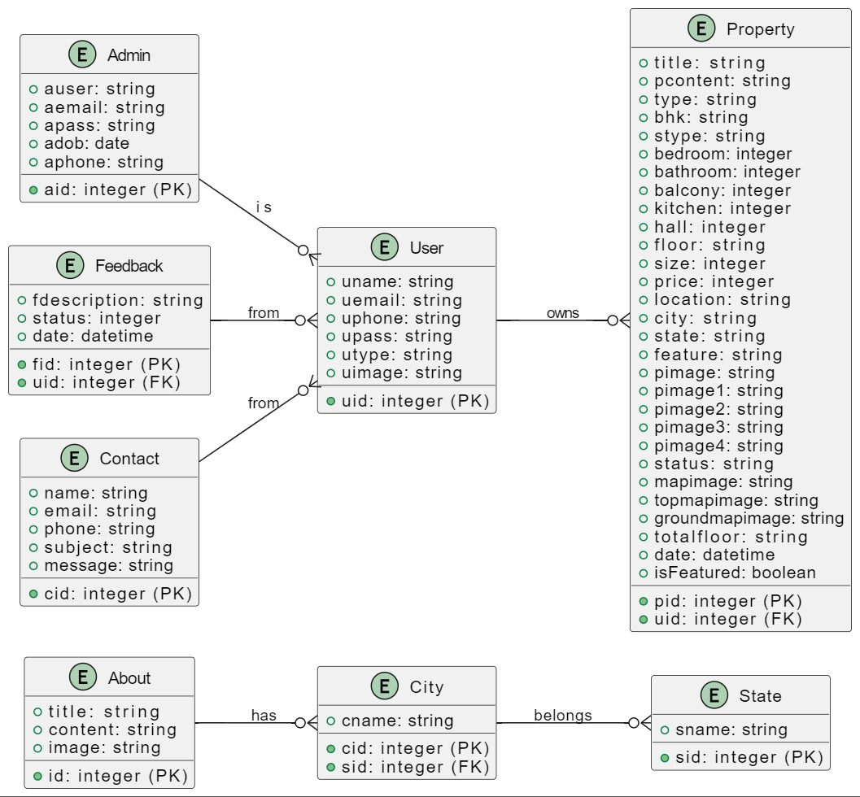

● Use Case Diagram (User)

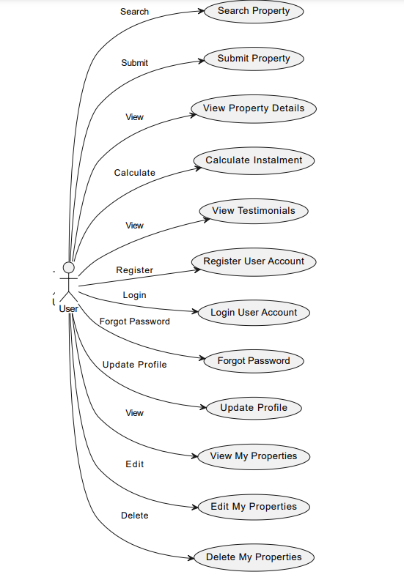

● Use Case Diagram (Admin)

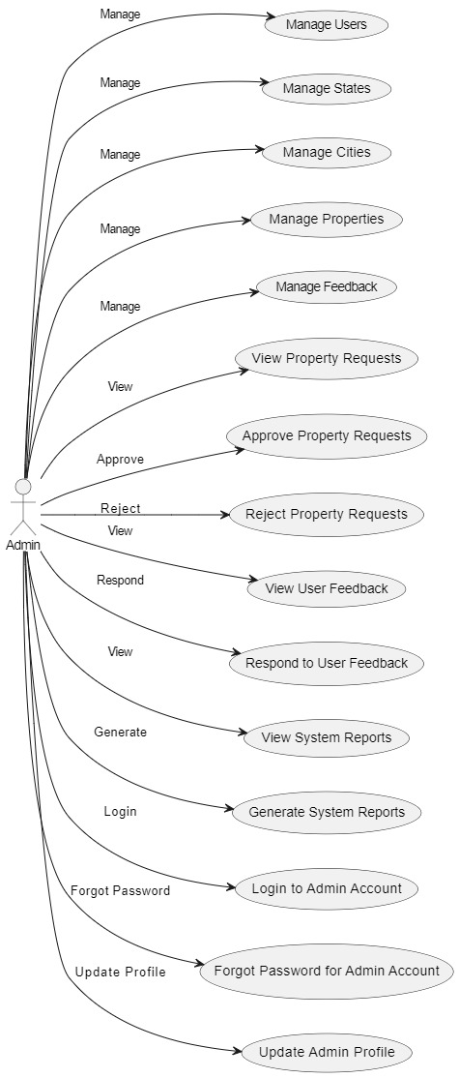
Data Flow Diagram
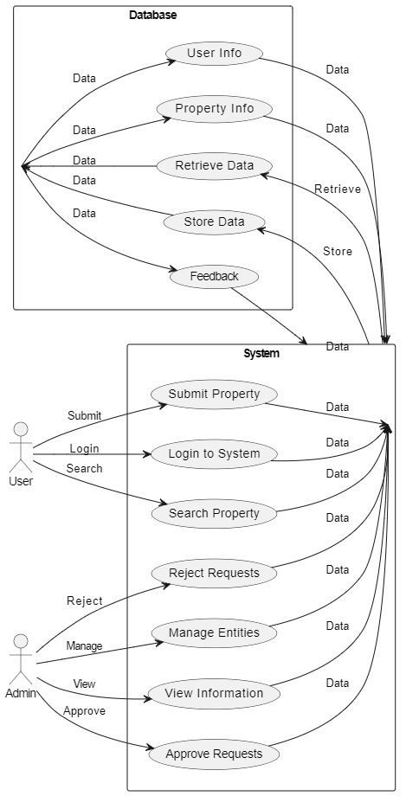
Level 1 DFD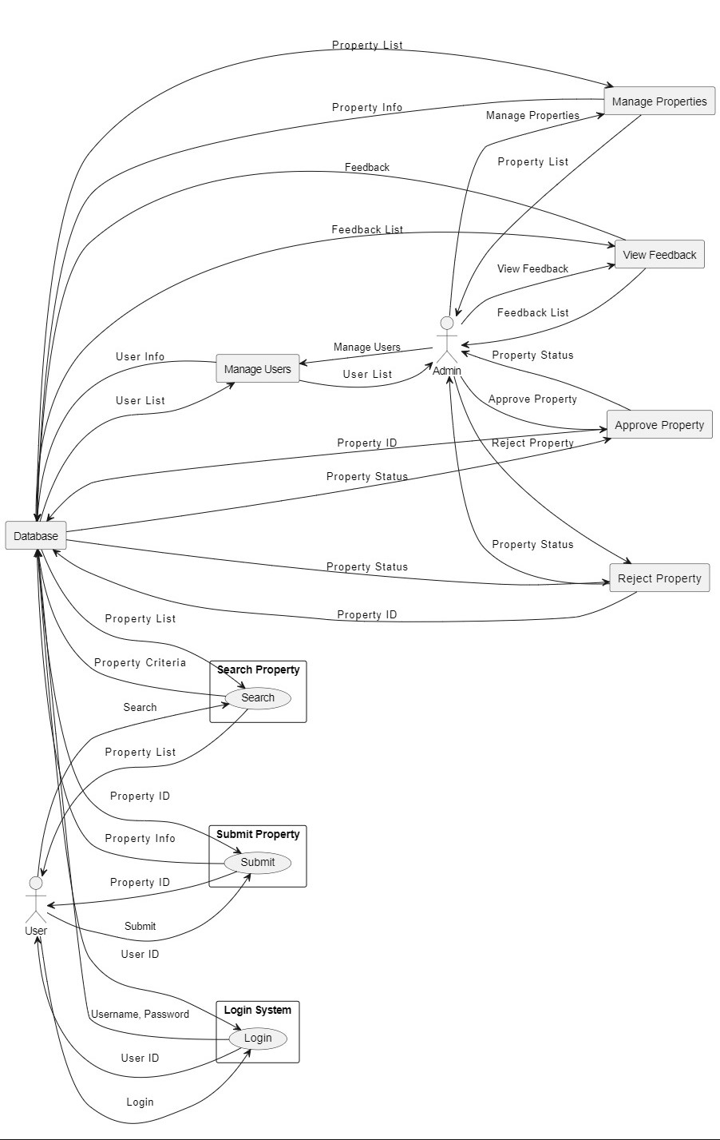
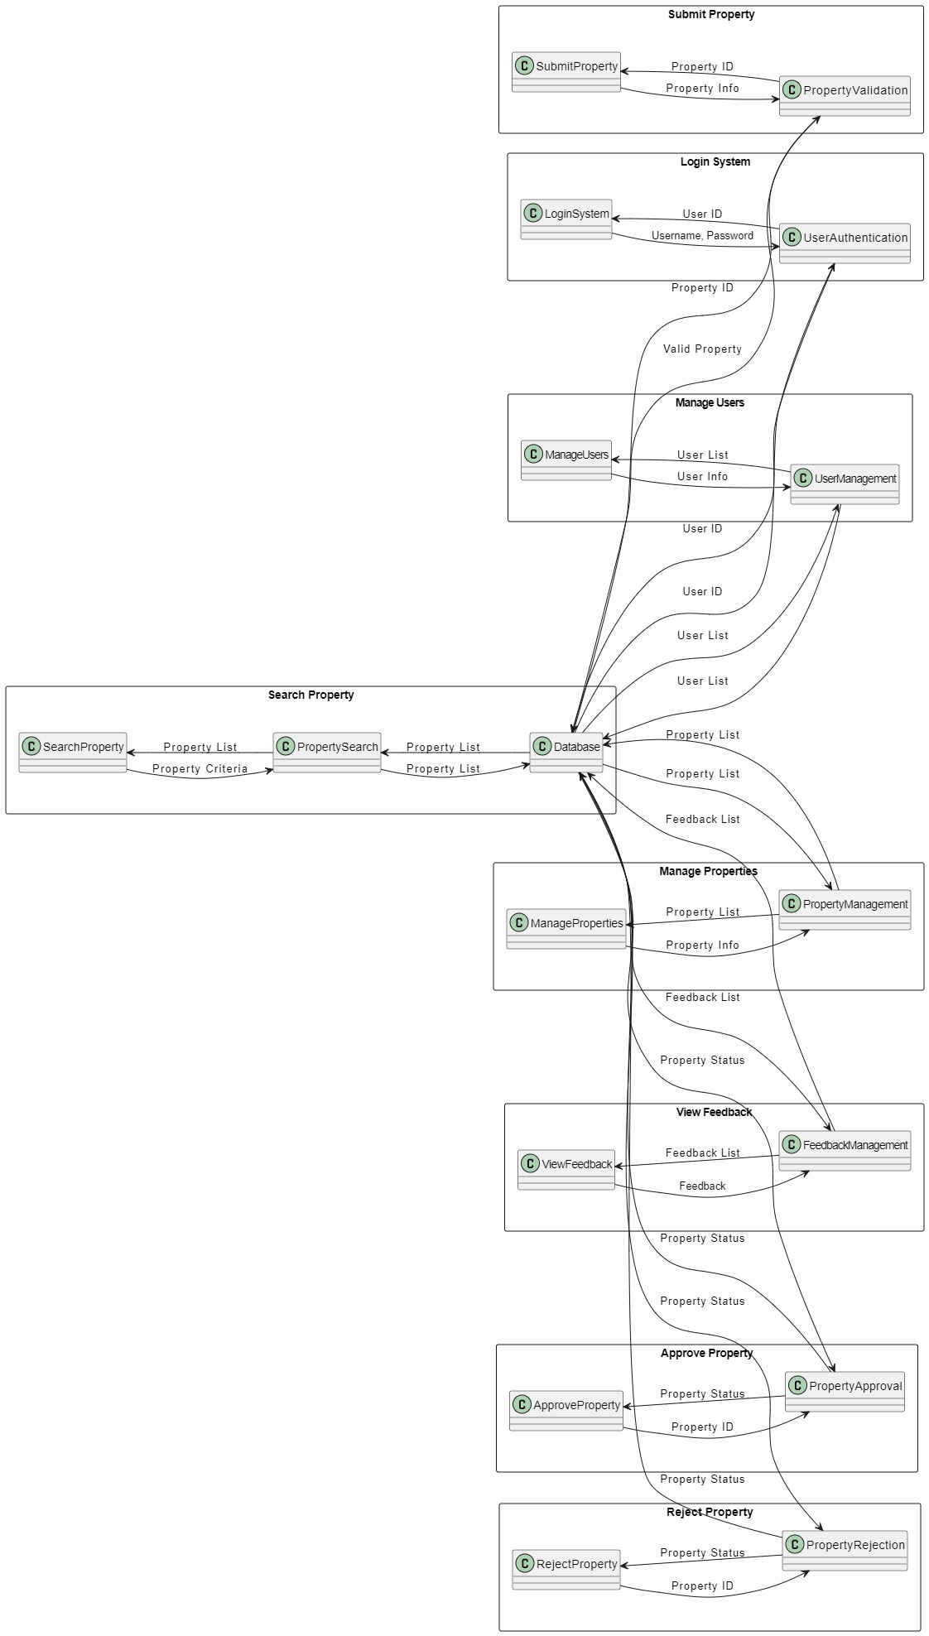
CODING
(User section)
REALESTATE-PHP/config.php

<?php

$con = mysqli_connect("localhost","root","","realestatephp");
if (mysqli_connect_errno())
{
echo "Failed to connect to MySQL: " . mysqli_connect_error();
}
?>

REALESTATE-PHP/index.php

<?php
ini_set('session.cache_limiter','public');
session_cache_limiter(false);
session_start();
include("config.php");

?>
<!DOCTYPE html>
<html lang="en">

<head>
<!-- -->
<!-- Required meta tags -->
<meta charset="utf-8">
<meta http-equiv="X-UA-Compatible" content="IE=edge">
<meta name="viewport" content="width=device-width, initial-scale=1, shrink-to-fit=no">

<!-- Meta Tags -->
<meta http-equiv="X-UA-Compatible" content="IE=edge">
<link rel="shortcut icon" href="images/favicon.ico">

<!-- Fonts
========================================================-->
<link href="https://fonts.googleapis.com/css?family=Muli:400,400i,500,600,700&amp;display=swap" rel="stylesheet">
<link href="https://fonts.googleapis.com/css?family=Comfortaa:400,700" rel="stylesheet">

<!-- Css Link
========================================================-->
<link rel="stylesheet" type="text/css" href="css/bootstrap.min.css">
<link rel="stylesheet" type="text/css" href="css/bootstrap-slider.css">
<link rel="stylesheet" type="text/css" href="css/jquery-ui.css">
<link rel="stylesheet" type="text/css" href="css/layerslider.css">
<link rel="stylesheet" type="text/css" href="css/color.css" id="color-change">
<link rel="stylesheet" type="text/css" href="css/owl.carousel.min.css">
<link rel="stylesheet" type="text/css" href="css/font-awesome.min.css">
<link rel="stylesheet" type="text/css" href="fonts/flaticon/flaticon.css">
<link rel="stylesheet" type="text/css" href="css/style.css">

<!-- Title
=========================================================-->
<title>Real Estate PHP</title>
</head>
<body>

<div id="page-wrapper">
<div class="row">
<!-- Header start -->
<?php include("include/header.php");?>
<!-- Header end -->

<!-- Banner Start -->
<div class="overlay-black w-100 slider-banner1 position-relative" style="background-image: url('images/banner/rshmpg.jpg'); background-size: cover; background-position: center center; background-repeat: no-repeat;">
<div class="container h-100">
<div class="row h-100 align-items-center">
<div class="col-lg-12">
<div class="text-white">
<h1 class="mb-4"><span class="text-success">Let us</span><br>
Guide you Home</h1><!-- -->
<form method="post" action="propertygrid.php">
<div class="row">
<div class="col-md-6 col-lg-2">
<div class="form-group">
<select class="form-control" name="type">
<option value="">Select Type</option>
<option value="apartment">Apartment</option>
<option value="flat">Flat</option>
<option value="building">Building</option>
<option value="house">House</option>
<option value="villa">Villa</option>
<option value="office">Office</option>
</select>
</div>
</div>
<div class="col-md-6 col-lg-2">
<div class="form-group">
<select class="form-control" name="stype">
<option value="">Select Status</option>
<option value="rent">Rent</option>
<option value="sale">Sale</option>
</select>
</div>
</div>
<div class="col-md-8 col-lg-6">
<div class="form-group">
<input type="text" class="form-control" name="city" placeholder="Enter City" required>
</div>
</div>
<div class="col-md-4 col-lg-2">
<div class="form-group">
<button type="submit" name="filter" class="btn btn-success w-100">Search Property</button>
</div>
</div>
</div>
</form>
</div>
</div>
</div>
</div>
</div>
<!-- Banner End -->

<!-- Text Block One
======================================================-->
<div class="full-row bg-gray">
<div class="container">
<div class="row">
<div class="col-lg-12"><!-- -->
<h2 class="text-secondary double-down-line text-center mb-5">What We Do</h2></div>
</div>
<div class="text-box-one">
<div class="row">
<div class="col-lg-3 col-md-6">
<div class="p-4 text-center hover-bg-white hover-shadow rounded mb-4 transation-3s">
<i class="flaticon-rent text-success flat-medium" aria-hidden="true"></i>
<h5 class="text-secondary hover-text-success py-3 m-0"><a href="#">Selling Service</a></h5>
<p>"We assist homeowners in selling their properties quickly and efficiently, ensuring you get the best possible price in the market."</p>
</div>
</div>
<div class="col-lg-3 col-md-6">
<div class="p-4 text-center hover-bg-white hover-shadow rounded mb-4 transation-3s">
<i class="flaticon-for-rent text-success flat-medium" aria-hidden="true"></i>
<h5 class="text-secondary hover-text-success py-3 m-0"><a href="#">Rental Service</a></h5>
<p>“Our team helps property owners find reliable tenants and manage rental agreements, making the rental process smooth and hassle-free.”
</p>
</div>
</div>
<div class="col-lg-3 col-md-6">
<div class="p-4 text-center hover-bg-white hover-shadow rounded mb-4 transation-3s">
<i class="flaticon-list text-success flat-medium" aria-hidden="true"></i>
<h5 class="text-secondary hover-text-success py-3 m-0"><a href="#">Property Listing</a></h5>
<p>“Browse through our extensive listings of properties for sale or rent. Our detailed listings include photos, descriptions, and all the necessary details to help you find your perfect home.”
</p>
</div>
</div>
<div class="col-lg-3 col-md-6">
<div class="p-4 text-center hover-bg-white hover-shadow rounded mb-4 transation-3s">
<i class="flaticon-diagram text-success flat-medium" aria-hidden="true"></i>
<h5 class="text-secondary hover-text-success py-3 m-0"><a href="#">Legal Investment</a></h5>
<p>“We provide expert advice and services for real estate investments, ensuring all legal aspects are covered to protect your investment and maximize returns.”</p>
</div>
</div>
</div>
</div>
</div>
</div>
<!----- Our Services ---->

<!-- Recent Properties -->
<div class="full-row">
<div class="container">
<div class="row">
<div class="col-md-12">
<h2 class="text-secondary double-down-line text-center mb-4">Recent Property</h2>
</div>

<div class="col-md-12"><!-- -->
<div class="tab-content mt-4" id="pills-tabContent">
<div class="tab-pane fade show active" id="pills-home" role="tabpanel" aria-labelledby="pills-home">
<div class="row">

<?php $query=mysqli_query($con,"SELECT property.*, user.uname,user.utype,user.uimage FROM `property`,`user` WHERE property.uid=user.uid ORDER BY date DESC LIMIT 9");
while($row=mysqli_fetch_array($query))
{
?>

<div class="col-md-6 col-lg-4"><!-- -->
<div class="featured-thumb hover-zoomer mb-4">
<div class="overlay-black overflow-hidden position-relative"> <img src="admin/property/<?php echo $row['18'];?>" alt="pimage">
<div class="featured bg-success text-white">New</div>
<div class="sale bg-success text-white text-capitalize">For <?php echo $row['5'];?></div>
<div class="price text-primary"><b>$<?php echo $row['13'];?> </b><span class="text-white"><?php echo $row['12'];?> Sqft</span></div>
</div>
<div class="featured-thumb-data shadow-one">
<div class="p-3">
<h5 class="text-secondary hover-text-success mb-2 text-capitalize"><a href="propertydetail.php?pid=<?php echo $row['0'];?>"><?php echo $row['1'];?></a></h5>
<span class="location text-capitalize"><i class="fas fa-map-marker-alt text-success"></i> <?php echo $row['14'];?></span> </div>
<div class="bg-gray quantity px-4 pt-4">
<ul>
<li><span><?php echo $row['12'];?></span> Sqft</li>
<li><span><?php echo $row['6'];?></span> Beds</li>
<li><span><?php echo $row['7'];?></span> Baths</li>
<li><span><?php echo $row['9'];?></span> Kitchen</li>
<li><span><?php echo $row['8'];?></span> Balcony</li>

</ul>
</div>
<div class="p-4 d-inline-block w-100">
<div class="float-left text-capitalize"><i class="fas fa-user text-success mr-1"></i>By : <?php echo $row['uname'];?></div>
<div class="float-right"><i class="far fa-calendar-alt text-success mr-1"></i> <?php echo date('d-m-Y', strtotime($row['date']));?></div>
</div>
</div>
</div>
</div>
<?php } ?>

</div>
</div>

</div>
</div>
</div>
</div>
</div>
<!-- Recent Properties -->

<!-- Why Choose Us -->
<div class="full-row living bg-one overlay-secondary-half" style="background-image: url('images/01.jpg'); background-size: cover; background-position: center center; background-repeat: no-repeat;">
<div class="container">
<div class="row">
<div class="col-md-12 col-lg-6">
<div class="living-list pr-4">
<h3 class="pb-4 mb-3 text-white">Why Choose Us</h3>
<ul>
<li class="mb-4 text-white d-flex">
<i class="flaticon-reward flat-medium float-left d-table mr-4 text-success" aria-hidden="true"></i>
<div class="pl-2">
<h5 class="mb-3">Top Rated</h5>
<p> “Our real estate agency is consistently rated highly by our clients for our exceptional service, market knowledge, and successful transactions.”
</p>
</div>
</li>
<li class="mb-4 text-white d-flex">
<i class="flaticon-real-estate flat-medium float-left d-table mr-4 text-success" aria-hidden="true"></i>
<div class="pl-2">
<h5 class="mb-3">Experience Quality</h5>
<p>“We pride ourselves on providing top-notch service and quality experiences to our clients, ensuring smooth and successful real estate transactions every time.”</p>
</div>
</li>
<li class="mb-4 text-white d-flex">
<i class="flaticon-seller flat-medium float-left d-table mr-4 text-success" aria-hidden="true"></i>
<div class="pl-2">
<h5 class="mb-3">Experienced Agents</h5>
<p> “Our team of experienced agents are experts in the real estate market, offering personalized advice and guidance to help you make informed decisions.”</p>
</div>
</li>
</ul>
</div>
</div>
</div>
</div>
</div>
<!-- why choose us -->

<!-- How it work -->
<div class="full-row">
<div class="container">
<div class="row">
<div class="col-lg-12">
<h2 class="text-secondary double-down-line text-center mb-5">How It Work</h2>
</div>
</div>
<div class="row">
<div class="col-md-4">
<div class="icon-thumb-one text-center mb-5">
<div class="bg-success text-white rounded-circle position-absolute z-index-9">1</div>
<div class="left-arrow"><i class="flaticon-investor flat-medium icon-success" aria-hidden="true"></i></div>
<h5 class="text-secondary mt-5 mb-4">Discussion</h5>
<p> Description: “We begin with an in-depth discussion to understand your needs and preferences. Our goal is to gather all the necessary details to provide you with the best possible service.” </p>
</div>
</div>
<div class="col-md-4">
<div class="icon-thumb-one text-center mb-5">
<div class="bg-success text-white rounded-circle position-absolute z-index-9">2</div>
<div class="left-arrow"><i class="flaticon-search flat-medium icon-success" aria-hidden="true"></i></div>
<h5 class="text-secondary mt-5 mb-4">Files Review</h5>
<p> “Our team meticulously reviews all relevant documents and information to ensure everything is in order. This step helps in identifying any potential issues early on.” </p>
</div>
</div>
<div class="col-md-4">
<div class="icon-thumb-one text-center mb-5">
<div class="bg-success text-white rounded-circle position-absolute z-index-9">3</div>
<div><i class="flaticon-handshake flat-medium icon-success" aria-hidden="true"></i></div>
<h5 class="text-secondary mt-5 mb-4">Acquire</h5>
<p> “Once everything is reviewed and approved, we assist you in acquiring your new property. We guide you through the final steps to make the process smooth and stress-free.” </p>
</div>
</div>
</div>
</div>
</div>

<!-- How It Work -->

<!-- Achievement-->
<div class="full-row overlay-secondary" style="background-image: url('images/breadcromb.jpg'); background-size: cover; background-position: center center; background-repeat: no-repeat;">
<div class="container">
<div class="fact-counter">
<div class="row">
<div class="col-md-3">
<div class="count wow text-center mb-sm-50" data-wow-duration="300ms"> <i class="flaticon-house flat-large text-white" aria-hidden="true"></i>
<?php
$query=mysqli_query($con,"SELECT count(pid) FROM property");
while($row=mysqli_fetch_array($query))
{
?>
<div class="count-num text-success my-4" data-speed="3000" data-stop="<?php
$total = $row[0];
echo $total;?>">0</div>
<?php } ?>
<div class="text-white h5">Property Available</div>
</div>
</div>
<div class="col-md-3">
<div class="count wow text-center mb-sm-50" data-wow-duration="300ms"> <i class="flaticon-house flat-large text-white" aria-hidden="true"></i>
<?php
$query=mysqli_query($con,"SELECT count(pid) FROM property where stype='sale'");
while($row=mysqli_fetch_array($query))
{
?>
<div class="count-num text-success my-4" data-speed="3000" data-stop="<?php
$total = $row[0];
echo $total;?>">0</div>
<?php } ?>
<div class="text-white h5">Sale Property Available</div>
</div>
</div>
<div class="col-md-3">
<div class="count wow text-center mb-sm-50" data-wow-duration="300ms"> <i class="flaticon-house flat-large text-white" aria-hidden="true"></i>
<?php
$query=mysqli_query($con,"SELECT count(pid) FROM property where stype='rent'");
while($row=mysqli_fetch_array($query))
{
?>
<div class="count-num text-success my-4" data-speed="3000" data-stop="<?php
$total = $row[0];
echo $total;?>">0</div>
<?php } ?>
<div class="text-white h5">Rent Property Available</div>
</div>
</div>
<div class="col-md-3">
<div class="count wow text-center mb-sm-50" data-wow-duration="300ms"> <i class="flaticon-man flat-large text-white" aria-hidden="true"></i>
<?php
$query=mysqli_query($con,"SELECT count(uid) FROM user");
while($row=mysqli_fetch_array($query))
{
?>
<div class="count-num text-success my-4" data-speed="3000" data-stop="<?php
$total = $row[0];
echo $total;?>">0</div>
<?php } ?>
<div class="text-white h5">Registered Users</div>
</div>
</div>

</div>
</div>
</div>
</div>

<!-- Popular Place -->
<div class="full-row bg-gray">
<div class="container">
<div class="row">
<div class="col-lg-12">
<h2 class="text-secondary double-down-line text-center mb-5">Popular Places</h2></div>
</div><!-- -->
<div class="col-lg-12">
<div class="row">
<div class="col-md-6 col-lg-3 pb-1">
<div class="overflow-hidden position-relative overlay-secondary hover-zoomer mx-n13 z-index-9"> <img src="images/thumbnail4/1.jpg" alt="">
<div class="text-white xy-center z-index-9 position-absolute text-center w-100">
<?php
$query=mysqli_query($con,"SELECT count(state), property.* FROM property where city='Olisphis'");
while($row=mysqli_fetch_array($query))
{
?>
<h4 class="hover-text-success text-capitalize"><a href="stateproperty.php?id=<?php echo $row['17']?>"><?php echo $row['state'];?></a></h4>
<span><?php
$total = $row[0];
echo $total;?> Properties Listed</span> </div>
<?php } ?>
</div>
</div><!-- -->
<div class="col-md-6 col-lg-3 pb-1">
<div class="overflow-hidden position-relative overlay-secondary hover-zoomer mx-n13 z-index-9"> <img src="images/thumbnail4/2.jpg" alt="">
<div class="text-white xy-center z-index-9 position-absolute text-center w-100">
<?php
$query=mysqli_query($con,"SELECT count(state), property.* FROM property where city='Awrerton'");
while($row=mysqli_fetch_array($query))
{
?>
<h4 class="hover-text-success text-capitalize"><a href="stateproperty.php?id=<?php echo $row['17']?>"><?php echo $row['state'];?></a></h4>
<span><?php
$total = $row[0];
echo $total;?> Properties Listed</span> </div>
<?php } ?>
</div>
</div>
<div class="col-md-6 col-lg-3 pb-1"><!-- -->
<div class="overflow-hidden position-relative overlay-secondary hover-zoomer mx-n13 z-index-9"> <img src="images/thumbnail4/3.jpg" alt="">
<div class="text-white xy-center z-index-9 position-absolute text-center w-100">
<?php
$query=mysqli_query($con,"SELECT count(state), property.* FROM property where city='Floson'");
while($row=mysqli_fetch_array($query))
{
?>
<h4 class="hover-text-success text-capitalize"><a href="stateproperty.php?id=<?php echo $row['17']?>"><?php echo $row['state'];?></a></h4>
<span><?php
$total = $row[0];
echo $total;?> Properties Listed</span> </div>
<?php } ?>
</div>
</div>
<div class="col-md-6 col-lg-3 pb-1">
<div class="overflow-hidden position-relative overlay-secondary hover-zoomer mx-n13 z-index-9"> <img src="images/thumbnail4/4.jpg" alt="">
<div class="text-white xy-center z-index-9 position-absolute text-center w-100">
<?php
$query=mysqli_query($con,"SELECT count(state), property.* FROM property where city='Ulmore'");
while($row=mysqli_fetch_array($query))
{
?>
<h4 class="hover-text-success text-capitalize"><a href="stateproperty.php?id=<?php echo $row['17']?>"><?php echo $row['state'];?></a></h4>
<span><?php
$total = $row[0];
echo $total;?> Properties Listed</span> </div>
<?php } ?>
</div>
</div><!-- -->
</div>
</div>
</div>
</div>
<!-- Popular Places -->

<!-- Testonomial -->
<div class="full-row">
<div class="container">
<div class="row">
<div class="col-lg-12">
<div class="content-sidebar p-4">
<div class="mb-3 col-lg-12">
<h4 class="double-down-line-left text-secondary position-relative pb-4 mb-4">Testimonial</h4>
<div class="recent-review owl-carousel owl-dots-gray owl-dots-hover-success">

<?php

$query=mysqli_query($con,"select feedback.*, user.* from feedback,user where feedback.uid=user.uid and feedback.status='1'");
while($row=mysqli_fetch_array($query))
{
?>
<div class="item">
<div class="p-4 bg-success down-angle-white position-relative">
<p class="text-white"><i class="fas fa-quote-left mr-2 text-white"></i><?php echo $row['2']; ?>. <i class="fas fa-quote-right mr-2 text-white"></i></p>
</div>
<div class="p-2 mt-4">
<span class="text-success d-table text-capitalize"><?php echo $row['uname']; ?></span> <span class="text-capitalize"><?php echo $row['utype']; ?></span>
</div>
</div>
<?php } ?>

</div>
</div>
</div>
</div>
</div>
</div>
</div>
<!-- Testonomial -->

<!-- Footer start-->
<?php include("include/footer.php");?>
<!-- Footer start-->

<!-- Scroll to top -->
<a href="#" class="bg-success text-white hover-text-secondary" id="scroll"><i class="fas fa-angle-up"></i></a>
<!-- End Scroll To top -->
</div>
</div>
<!-- Wrapper End -->

<!-- Js Link
============================================================-->
<script src="js/jquery.min.js"></script>
<!--jQuery Layer Slider -->
<script src="js/greensock.js"></script>
<script src="js/layerslider.transitions.js"></script>
<script src="js/layerslider.kreaturamedia.jquery.js"></script>
<!--jQuery Layer Slider -->
<script src="js/popper.min.js"></script>
<script src="js/bootstrap.min.js"></script>
<script src="js/owl.carousel.min.js"></script>
<script src="js/tmpl.js"></script>
<script src="js/jquery.dependClass-0.1.js"></script>
<script src="js/draggable-0.1.js"></script>
<script src="js/jquery.slider.js"></script>
<script src="js/wow.js"></script>
<script src="js/YouTubePopUp.jquery.js"></script>
<script src="js/validate.js"></script>
<script src="js/jquery.cookie.js"></script>
<script src="js/custom.js"></script>
</body>

</html>

REALESTATE-PHP/include/header.php

<header id="header" class="transparent-header-modern fixed-header-bg-white w-100">
<div class="top-header bg-secondary">
<div class="container">
<div class="row">
<div class="col-md-8">
<ul class="top-contact list-text-white d-table">
<li><a href="#"><i class=" text-success mr-1"></i>BlockFernsReality</a></li>

</ul>
</div>
<div class="col-md-4">
<div class="top-contact float-right">
<ul class="list-text-white d-table">
<li><i class="fas fa-user text-success mr-1"></i>
<?php if(isset($_SESSION['uemail']))
{ ?>
<a href="logout.php">Logout</a>&nbsp;&nbsp;<?php } else { ?>
<a href="login.php">Login</a>&nbsp;&nbsp; | </li>
<li><i class="fas fa-user-plus text-success mr-1"></i><a href="register.php"> Register </li><?php } ?>
<li>|</li>
<li><i class="fas fa-user text-success mr-1"></i><a href="admin/index.php">Administrator</li>
</ul>
</div>
</div>
</div>
</div>
</div>
<div class="main-nav secondary-nav hover-success-nav py-2">
<div class="container">
<div class="row">
<div class="col-lg-12">
<nav class="navbar navbar-expand-lg navbar-light p-0"> <a class="navbar-brand position-relative" href="index.php"><img class="nav-logo" src="images/logo/blockfernslogo.jpg" alt=""></a>
<button class="navbar-toggler" type="button" data-toggle="collapse" data-target="#navbarSupportedContent" aria-controls="navbarSupportedContent" aria-expanded="false" aria-label="Toggle navigation"> <span class="navbar-toggler-icon"></span> </button>
<div class="collapse navbar-collapse" id="navbarSupportedContent">
<ul class="navbar-nav mr-auto">
<li class="nav-item dropdown"> <a class="nav-link" href="index.php" role="button" aria-haspopup="true" aria-expanded="false">Home</a></li>

<li class="nav-item"> <a class="nav-link" href="about.php">About</a> </li>

<li class="nav-item"> <a class="nav-link" href="contact.php">Contact</a> </li>

<li class="nav-item"> <a class="nav-link" href="property.php">Properties</a> </li>

<li class="nav-item"> <a class="nav-link" href="agent.php">Agent</a> </li>

<?php if(isset($_SESSION['uemail']))
{ ?>
<li class="nav-item dropdown">
<a class="nav-link dropdown-toggle" href="#" role="button" data-toggle="dropdown" aria-haspopup="true" aria-expanded="false">My Account</a>
<ul class="dropdown-menu">
<li class="nav-item"> <a class="nav-link" href="profile.php">Profile</a> </li>
<!-- <li class="nav-item"> <a class="nav-link" href="request.php">Property Request</a> </li> -->
<li class="nav-item"> <a class="nav-link" href="feature.php">Your Property</a> </li>
<li class="nav-item"> <a class="nav-link" href="logout.php">Logout</a> </li>
</ul>
</li>
<?php } else { ?>
<li class="nav-item"> <a class="nav-link" href="login.php">Login/Register</a> </li>
<?php } ?>

</ul>

<a class="btn btn-success d-none d-xl-block" style="border-radius:30px;" href="submitproperty.php">Submit Peoperty</a>
</div>
</nav>
</div>
</div>
</div>
</div>
</header>

REALESTATE-PHP/include/footer.php

<footer class="full-row bg-secondary p-0">
<div class="container">
<div class="row">
<div class="col-lg-12">
<div class="divider py-40">
<div class="row">
<div class="col-md-12 col-lg-4">
<div class="footer-widget mb-4">

<p class="pb-20 text-white">“At BlockFernsReality, we are dedicated to providing exceptional real estate services to our clients. With years of experience and a deep understanding of the market, we strive to make the buying, selling, and renting process as seamless as possible. Our commitment to integrity, professionalism, and customer satisfaction sets us apart in the industry. Whether you are looking to find your dream home, sell your property, or make a sound investment, our team is here to guide you every step of the way.”</p>

</div>
</div>
<div class="col-md-12 col-lg-8">
<div class="row">
<div class="col-md-4 col-lg-4">
<div class="footer-widget footer-nav mb-4">
<h4 class="widget-title text-white double-down-line-left position-relative">Support</h4>
<ul class="hover-text-primary">
<li><a href="#" class="text-white">Forum</a></li>
<li><a href="#" class="text-white">Terms and Condition</a></li>
<li><a href="#" class="text-white">Frequenlty Asked Question</a></li>
<li><a href="contact.php" class="text-white">Contact</a></li>
</ul>
</div>
</div>
<div class="col-md-4 col-lg-4">
<div class="footer-widget footer-nav mb-4">
<h4 class="widget-title text-white double-down-line-left position-relative">Quick Links</h4>
<ul class="hover-text-primary">
<li><a href="about.php" class="text-white">About Us</a></li>
<li><a href="#" class="text-white">Featured Property</a></li>
<li><a href="#" class="text-white">Submit Property</a></li>
<li><a href="agent.php" class="text-white">Our Agents</a></li>
</ul>
</div>
</div>
<div class="col-md-4 col-lg-4">
<div class="footer-widget">
<h4 class="widget-title text-white double-down-line-left position-relative">Contact Us</h4>
<ul class="text-white">
<li class="hover-text-primary"><i class="fas fa-map-marker-alt text-white mr-2 font-13 mt-1"></i>27 Church street ,Bangalore</li>
<li class="hover-text-primary"> <i class="fas fa-phone-alt text-white mr-2 font-13 mt-1"></i><a href="tel:+91 1234556789"><i class="text-white">+91 1234556789</i></a></li>
<li class="hover-text-primary"> <i class="fas fa-phone-alt text-white mr-2 font-13 mt-1"></i><a href="tel:+91 9876554321"><i class="text-white">+91 9876554321</i></a></li>
<li class="hover-text-primary"><i class="fas fa-envelope text-white mr-2 font-13 mt-1"></i>BlockFernsReality@gmail.com</li>
<li class="hover-text-primary"> <i class="fab fa-instagram text-white mr-2 font-13 mt-1"></i><a href="https://www.instagram.com/blockfernsreality?igsh=MTQya2J3eXYzY2NuMQ=="><i class="text-white">BlockFernsReality</i></a></li>
</ul>
</div>
</div>
</div>
</div>
</div>
</div>
</div>
</div>
<div class="row copyright">
<div class="col-sm-6"> <span class="text-white">© <?php echo date('Y');?> Real Estate Website - Developed By Syed Ibrahim & Mohammed Afreed</span> </div>
<div class="col-sm-6">
<ul class="line-menu text-white hover-text-primary float-right">
<li><a href="#">Privacy & Policy</a></li>
<li>|</li>
<li><a href="#"> Site Map</a></li>
</ul>
</div>
</div>
</div>
</footer>

REALESTATE-PHP/about.php

<?php
ini_set('session.cache_limiter','public');
session_cache_limiter(false);
session_start();
include("config.php");
?>
<!DOCTYPE html>
<html lang="en">

<head>
<!-- Required meta tags -->
<meta charset="utf-8">
<meta http-equiv="X-UA-Compatible" content="IE=edge">
<meta name="viewport" content="width=device-width, initial-scale=1, shrink-to-fit=no">

<!-- Meta Tags -->
<meta http-equiv="X-UA-Compatible" content="IE=edge">
<meta name="description" content="Real Estate PHP">
<meta name="keywords" content="">
<meta name="author" content="Unicoder">
<link rel="shortcut icon" href="images/favicon.ico">

<!-- Fonts -->
<link href="https://fonts.googleapis.com/css?family=Muli:400,400i,500,600,700&amp;display=swap" rel="stylesheet">
<link href="https://fonts.googleapis.com/css?family=Comfortaa:400,700" rel="stylesheet">

<!-- Css Link -->

<link rel="stylesheet" type="text/css" href="css/bootstrap.min.css">
<link rel="stylesheet" type="text/css" href="css/bootstrap-slider.css">
<link rel="stylesheet" type="text/css" href="css/jquery-ui.css">
<link rel="stylesheet" type="text/css" href="css/layerslider.css">
<link rel="stylesheet" type="text/css" href="css/color.css" id="color-change">
<link rel="stylesheet" type="text/css" href="css/owl.carousel.min.css">
<link rel="stylesheet" type="text/css" href="css/font-awesome.min.css">
<link rel="stylesheet" type="text/css" href="fonts/flaticon/flaticon.css">
<link rel="stylesheet" type="text/css" href="css/style.css">

<!-- Title -->
<title>Real Estate PHP</title>
</head>
<body>
<div id="page-wrapper">
<div class="row">
<!-- Header start -->
<?php include("include/header.php");?>
<!-- Header end -->
<!-- About Our Company -->
<div class="full-row">
<div class="container">

<?php

$query=mysqli_query($con,"SELECT * FROM about");
while($row=mysqli_fetch_array($query))
{
?>
<div class="row">
<div class="col-md-12 col-lg-12">
<h3 class="double-down-line-left text-secondary position-relative pb-4 mb-4"><?php echo $row['1'];?></h3>
</div>
</div>
<div class="row about-company">
<div class="col-md-12 col-lg-7">
<div class="about-content">
<?php echo $row['2'];?>
</div>
</div>
<div class="col-md-12 col-lg-5 mt-5">
<div class="about-img"> <img src="admin/upload/<?php echo $row['3'];?>" alt="about image"> </div>
</div>
</div>

<?php } ?>

</div>
</div>
<!-- About Our Company -->

<!-- Footer start-->
<?php include("include/footer.php");?>
<!-- Footer start-->

<!-- Scroll to top -->
<a href="#" class="bg-secondary text-white hover-text-secondary" id="scroll"><i class="fas fa-angle-up"></i></a>
<!-- End Scroll To top -->
</div>
</div>
<!-- Wrapper End -->

<!-- Js Link
============================================================-->
<script src="js/jquery.min.js"></script>
<!--jQuery Layer Slider -->
<script src="js/greensock.js"></script>
<script src="js/layerslider.transitions.js"></script>
<script src="js/layerslider.kreaturamedia.jquery.js"></script>
<!--jQuery Layer Slider -->
<script src="js/popper.min.js"></script>
<script src="js/bootstrap.min.js"></script>
<script src="js/owl.carousel.min.js"></script>
<script src="js/tmpl.js"></script>
<script src="js/jquery.dependClass-0.1.js"></script>
<script src="js/draggable-0.1.js"></script>
<script src="js/jquery.slider.js"></script>
<script src="js/wow.js"></script>
<script src="js/jquery.cookie.js"></script>
<script src="js/custom.js"></script>
</body>
</html>

REALESTATE-PHP/agent.php
<?php
ini_set('session.cache_limiter','public');
session_cache_limiter(false);
session_start();
include("config.php");
///code
?>
<!DOCTYPE html>
<html lang="en">

<head>
<!-- Required meta tags -->
<meta charset="utf-8">
<meta http-equiv="X-UA-Compatible" content="IE=edge">
<meta name="viewport" content="width=device-width, initial-scale=1, shrink-to-fit=no">

<!-- Meta Tags -->
<meta http-equiv="X-UA-Compatible" content="IE=edge">

<link rel="shortcut icon" href="images/favicon.ico">

<!-- Fonts
========================================================-->
<link href="https://fonts.googleapis.com/css?family=Muli:400,400i,500,600,700&amp;display=swap" rel="stylesheet">
<link href="https://fonts.googleapis.com/css?family=Comfortaa:400,700" rel="stylesheet">

<!-- Css Link
========================================================-->
<link rel="stylesheet" type="text/css" href="css/bootstrap.min.css">
<link rel="stylesheet" type="text/css" href="css/bootstrap-slider.css">
<link rel="stylesheet" type="text/css" href="css/jquery-ui.css">
<link rel="stylesheet" type="text/css" href="css/layerslider.css">
<link rel="stylesheet" type="text/css" href="css/color.css" id="color-change">
<link rel="stylesheet" type="text/css" href="css/owl.carousel.min.css">
<link rel="stylesheet" type="text/css" href="css/font-awesome.min.css">
<link rel="stylesheet" type="text/css" href="fonts/flaticon/flaticon.css">
<link rel="stylesheet" type="text/css" href="css/style.css">

<!-- Title
=========================================================-->
<title>Real Estate PHP</title>
</head>
<body>
<div id="page-wrapper">
<div class="row">
<!-- Header One -->
<!-- Header start -->
<?php include("include/header.php");?>
<!-- Header end -->
<div class="full-row">
<div class="container">
<div class="row">
<div class="col-lg-12">
<h2 class="text-secondary double-down-line text-center mb-5">Agent</h2>
</div>
</div>
<div class="row">

<?php
$query=mysqli_query($con,"SELECT * FROM user WHERE utype='agent'");
while($row=mysqli_fetch_array($query))
{
?>

<div class="col-md-6 col-lg-4">
<div class="hover-zoomer bg-white shadow-one mb-4">
<div class="overflow-hidden"> <img src="admin/user/<?php echo $row['6'];?>" alt="aimage"> </div>
<div class="py-3 text-center">
<h5 class="text-secondary hover-text-success"><a href="#"><?php echo $row['1'];?></a></h5>
<span>Real Estate - Agent</span> </div>
</div>
</div>

<?php } ?>

</div>
</div>
</div>

<!-- Footer start-->
<?php include("include/footer.php");?>
<!-- Footer start-->

<!-- Scroll to top -->
<a href="#" class="bg-secondary text-white hover-text-secondary" id="scroll"><i class="fas fa-angle-up"></i></a>
<!-- End Scroll To top -->
</div>
</div>
<!-- Wrapper End -->

<!-- Js Link
============================================================-->
<script src="js/jquery.min.js"></script>
<!--jQuery Layer Slider -->
<script src="js/greensock.js"></script>
<script src="js/layerslider.transitions.js"></script>
<script src="js/layerslider.kreaturamedia.jquery.js"></script>
<!--jQuery Layer Slider -->
<script src="js/popper.min.js"></script>
<script src="js/bootstrap.min.js"></script>
<script src="js/owl.carousel.min.js"></script>
<script src="js/tmpl.js"></script>
<script src="js/jquery.dependClass-0.1.js"></script>
<script src="js/draggable-0.1.js"></script>
<script src="js/jquery.slider.js"></script>
<script src="js/wow.js"></script>
<script src="js/custom.js"></script>
</body>
</html>

REALESTATE-PHP/calc.php
<?php
ini_set('session.cache_limiter','public');
session_cache_limiter(false);
session_start();
include("config.php");

// codeing

if(isset($_REQUEST['calc']))
{
$amount=$_REQUEST['amount'];
$mon=$_REQUEST['month'];
$int=$_REQUEST['interest'];

$interest = $amount * $int/100;
$pay = $amount + $interest;
$month = $pay / $mon;

}
?>
<!DOCTYPE html>
<html lang="en">

<head>
<!-- Required meta tags -->
<meta charset="utf-8">
<meta http-equiv="X-UA-Compatible" content="IE=edge">
<meta name="viewport" content="width=device-width, initial-scale=1, shrink-to-fit=no">

<!-- Meta Tags -->
<meta http-equiv="X-UA-Compatible" content="IE=edge">
<link rel="shortcut icon" href="images/favicon.ico">

<!-- Fonts
========================================================-->
<link href="https://fonts.googleapis.com/css?family=Muli:400,400i,500,600,700&amp;display=swap" rel="stylesheet">
<link href="https://fonts.googleapis.com/css?family=Comfortaa:400,700" rel="stylesheet">

<!-- Css Link
========================================================-->
<link rel="stylesheet" type="text/css" href="css/bootstrap.min.css">
<link rel="stylesheet" type="text/css" href="css/bootstrap-slider.css">
<link rel="stylesheet" type="text/css" href="css/jquery-ui.css">
<link rel="stylesheet" type="text/css" href="css/layerslider.css">
<link rel="stylesheet" type="text/css" href="css/color.css">
<link rel="stylesheet" type="text/css" href="css/owl.carousel.min.css">
<link rel="stylesheet" type="text/css" href="css/font-awesome.min.css">
<link rel="stylesheet" type="text/css" href="fonts/flaticon/flaticon.css">
<link rel="stylesheet" type="text/css" href="css/style.css">
<link rel="stylesheet" type="text/css" href="css/login.css">

<!-- Title
=========================================================-->
<title>Real Estate PHP</title>
</head>
<body>
<div id="page-wrapper">
<div class="row">
<!-- Header start -->
<?php include("include/header.php");?>
<!-- Header end -->

<!-- Submit property -->
<div class="full-row bg-gray">
<div class="container">
<div class="row mb-5">
<div class="col-lg-12">
<h2 class="text-secondary double-down-line text-center">EMI Calculator</h2>
</div>
</div>
<center>
<table class="items-list col-lg-6 table-hover" style="border-collapse:inherit;">
<thead>
<tr class="bg-secondary">
<th class="text-white font-weight-bolder">Term</th>
<th class="text-white font-weight-bolder">Amount</th>
</tr>
</thead>
<tbody>

<tr class="text-center font-18">
<td><b>Amount</b></td>
<td><b><?php echo '$'.$amount ; ?></b></td>
</tr>
<tr class="text-center">
<td><b>Total Duration</b></td>
<td><b><?php echo $mon.' Months' ; ?></b></td>
</tr>
<tr class="text-center">
<td><b>Interest Rate</b></td>
<td><b><?php echo $int.'%' ; ?></b></td>
</tr>
<tr class="text-center">
<td><b>Total Interest</b></td>
<td><b><?php echo '₹'.$interest ; ?></b></td>
</tr>
<tr class="text-center">
<td><b>Total Amount</b></td>
<td><b><?php echo '₹'.$pay ; ?></b></td>
</tr>
<tr class="text-center">
<td><b>Pay Per Month (EMI)</b></td>
<td><b><?php echo '₹'.$month ; ?></b></td>
</tr>

</tbody>
</table>
</center>
</div>
</div>
<!-- Submit property -->
<!-- Footer start-->
<?php include("include/footer.php");?>
<!-- Footer start-->

<!-- Scroll to top -->
<a href="#" class="bg-secondary text-white hover-text-secondary" id="scroll"><i class="fas fa-angle-up"></i></a>
<!-- End Scroll To top -->
</div>
</div>
<!-- Wrapper End -->

<!-- Js Link
============================================================-->
<script src="js/jquery.min.js"></script>
<!--jQuery Layer Slider -->
<script src="js/greensock.js"></script>
<script src="js/layerslider.transitions.js"></script>
<script src="js/layerslider.kreaturamedia.jquery.js"></script>
<!--jQuery Layer Slider -->
<script src="js/popper.min.js"></script>
<script src="js/bootstrap.min.js"></script>
<script src="js/owl.carousel.min.js"></script>
<script src="js/tmpl.js"></script>
<script src="js/jquery.dependClass-0.1.js"></script>
<script src="js/draggable-0.1.js"></script>
<script src="js/jquery.slider.js"></script>
<script src="js/wow.js"></script>
<script src="js/custom.js"></script>
</body>
</html>

REALESTATE-PHP/contact.php

<?php
include("config.php");
$error="";
$msg="";
if(isset($_POST['send']))
{
$name=$_POST['name'];
$email=$_POST['email'];
$phone=$_POST['phone'];
$subject=$_POST['subject'];
$message=$_POST['message'];

if(!empty($name) && !empty($email) && !empty($phone) && !empty($subject) && !empty($message))
{

$sql="INSERT INTO contact (name,email,phone,subject,message) VALUES ('$name','$email','$phone','$subject','$message')";
$result=mysqli_query($con, $sql);
if($result){
$msg = "<p class='alert alert-success'>Message Send Successfully</p> ";
}
else{
$error = "<p class='alert alert-warning'>Message Not Send Successfully</p> ";
}
}else{
$error = "<p class='alert alert-warning'>Please Fill all the fields</p>";
}
}
?>
<!DOCTYPE html>
<html lang="en">
<head>
<!-- Required meta tags -->
<meta charset="utf-8">
<meta http-equiv="X-UA-Compatible" content="IE=edge">
<meta name="viewport" content="width=device-width, initial-scale=1, shrink-to-fit=no">

<!-- Meta Tags -->
<meta http-equiv="X-UA-Compatible" content="IE=edge">
<link rel="shortcut icon" href="images/favicon.ico">

<!-- Fonts
========================================================-->
<link href="https://fonts.googleapis.com/css?family=Muli:400,400i,500,600,700&display=swap" rel="stylesheet">
<link href="https://fonts.googleapis.com/css?family=Comfortaa:400,700" rel="stylesheet">
<!-- -->
<!-- Css Link
========================================================-->
<link rel="stylesheet" type="text/css" href="css/bootstrap.min.css">
<link rel="stylesheet" type="text/css" href="css/bootstrap-slider.css">
<link rel="stylesheet" type="text/css" href="css/jquery-ui.css">
<link rel="stylesheet" type="text/css" href="css/layerslider.css">
<link rel="stylesheet" type="text/css" href="css/color.css" id="color-change">
<link rel="stylesheet" type="text/css" href="css/owl.carousel.min.css">
<link rel="stylesheet" type="text/css" href="css/font-awesome.min.css">
<link rel="stylesheet" type="text/css" href="fonts/flaticon/flaticon.css">
<link rel="stylesheet" type="text/css" href="css/style.css">

<!-- Title
=========================================================-->
<title>Real Estate PHP</title>
</head>
<body>

<div id="page-wrapper">
<div class="row">
<!-- Header start -->
<?php include("include/header.php");?>
<!-- Header end -->

<!-- Contact Information -->
<div class="full-row">
<div class="container">
<div class="row">
<div class="col-lg-4 mb-5 bg-secondary">
<div class="contact-info">
<h3 class="mb-4 mt-4 text-white">Contacts</h3>

<ul>
<li class="d-flex mb-4"> <i class="fas fa-map-marker-alt text-white mr-2 font-13 mt-1"></i>
<div class="contact-address">
<h5 class="text-white">Address</h5>
<span class="text-white">27 church Street, Bangalore</span> <br>
<span class="text-white">#24 Indraganar, Bangalore</span>
</div>
</li>
<li class="d-flex mb-4"> <i class="fas fa-phone-alt text-white mr-2 font-13 mt-1"></i>
<div class="contact-address">
<h5 class="text-white">Call Us</h5>
<span class="d-table text-white">+91 1234567890</span>
<span class="text-white">+91 1234567890</span>
</div>
</li>
<li class="d-flex mb-4"> <i class="fas fa-envelope text-white mr-2 font-13 mt-1"></i>
<div class="contact-address">
<h5 class="text-white">Email Adderss</h5>
<span class="d-table text-white">BlockFernsReality@gmail.com</span>

</div>
</li>
</ul>
</div>
</div>
<div class="col-lg-1"></div>
<div class="col-md-12 col-lg-7">
<div class="container">
<div class="row">
<div class="col-lg-12">
<h2 class="text-secondary double-down-line text-center mb-5">Get In Touch</h2>
<?php echo $msg; ?><?php echo $error; ?>
</div>
</div><!-- -->
<div class="row">
<div class="col-md-12">
<form class="w-100" action="#" method="post">
<div class="row">
<div class="row mb-4">
<div class="form-group col-lg-6">
<input type="text" name="name" class="form-control" placeholder="Your Name*">
</div>
<div class="form-group col-lg-6">
<input type="text" name="email" class="form-control" placeholder="Email Address*">
</div>
<div class="form-group col-lg-6">
<input type="text" name="phone" class="form-control" placeholder="Phone" maxlength="10">
</div>
<div class="form-group col-lg-6">
<input type="text" name="subject" class="form-control" placeholder="Subject">
</div>
<div class="col-lg-12">
<div class="form-group">
<textarea name="message" class="form-control" rows="5" placeholder="Type Comments..."></textarea>
</div>
</div>
</div>
<button type="submit" value="send message" name="send" class="btn btn-success">Send Message</button>
</div>
</form>
</div>
</div>
</div>
</div>
</div>
</div>
</div><!-- -->
<!-- Contact Inforamtion -->

<!-- Footer start-->
<?php include("include/footer.php");?>
<!-- Footer start-->

<!-- Scroll to top -->
<a href="#" class="bg-secondary text-white hover-text-secondary" id="scroll"><i class="fas fa-angle-up"></i></a>
<!-- End Scroll To top -->
</div>
</div>
<!-- Wrapper End -->

<!-- Js Link
============================================================-->
<script src="js/jquery.min.js"></script>
<!--jQuery Layer Slider -->
<script src="js/greensock.js"></script>
<script src="js/layerslider.transitions.js"></script>
<script src="js/layerslider.kreaturamedia.jquery.js"></script>
<!--jQuery Layer Slider -->
<script src="js/popper.min.js"></script>
<script src="js/bootstrap.min.js"></script>
<script src="js/owl.carousel.min.js"></script>
<script src="js/tmpl.js"></script>
<script src="js/jquery.dependClass-0.1.js"></script>
<script src="js/draggable-0.1.js"></script>
<script src="js/jquery.slider.js"></script>
<script src="js/wow.js"></script>
<script src="js/jquery.cookie.js"></script>
<script src="js/custom.js"></script>

</body>
</html>

REALESTATE-PHP/feature.php

<?php
ini_set('session.cache_limiter','public');
session_cache_limiter(false);
session_start();
include("config.php");
if(!isset($_SESSION['uemail']))
{
header("location:login.php");
}
?>
<!DOCTYPE html>
<html lang="en">

<head>
<!-- Required meta tags -->
<meta charset="utf-8">
<meta http-equiv="X-UA-Compatible" content="IE=edge">
<meta name="viewport" content="width=device-width, initial-scale=1, shrink-to-fit=no">

<!-- Meta Tags -->
<meta http-equiv="X-UA-Compatible" content="IE=edge">
<link rel="shortcut icon" href="images/favicon.ico">

<!-- Fonts
========================================================-->
<link href="https://fonts.googleapis.com/css?family=Muli:400,400i,500,600,700&amp;display=swap" rel="stylesheet">
<link href="https://fonts.googleapis.com/css?family=Comfortaa:400,700" rel="stylesheet">

<!-- Css Link
========================================================-->
<link rel="stylesheet" type="text/css" href="css/bootstrap.min.css">
<link rel="stylesheet" type="text/css" href="css/bootstrap-slider.css">
<link rel="stylesheet" type="text/css" href="css/jquery-ui.css">
<link rel="stylesheet" type="text/css" href="css/layerslider.css">
<link rel="stylesheet" type="text/css" href="css/color.css">
<link rel="stylesheet" type="text/css" href="css/owl.carousel.min.css">
<link rel="stylesheet" type="text/css" href="css/font-awesome.min.css">
<link rel="stylesheet" type="text/css" href="fonts/flaticon/flaticon.css">
<link rel="stylesheet" type="text/css" href="css/style.css">
<link rel="stylesheet" type="text/css" href="css/login.css">

<!-- Title
=========================================================-->
<title>Real Estate PHP</title>
</head>
<body>
<div id="page-wrapper">
<div class="row">
<!-- Header start -->
<?php include("include/header.php");?>
<!-- Header end -->

<!-- Banner --->
<div class="banner-full-row page-banner" style="background-image:url('images/breadcromb.jpg');">
<div class="container">
<div class="row">
<div class="col-md-6">
<h2 class="page-name float-left text-white text-uppercase mt-1 mb-0"><b>User Listed Property</b></h2>
</div>
<div class="col-md-6">
<nav aria-label="breadcrumb" class="float-left float-md-right">
<ol class="breadcrumb bg-transparent m-0 p-0">
<li class="breadcrumb-item text-white"><a href="#">Home</a></li>
<li class="breadcrumb-item active">User Listed Property</li>
</ol>
</nav>
</div>
</div>
</div>
</div>
<!-- Banner --->

<!-- Submit property -->
<div class="full-row bg-gray">
<div class="container"><!-- -->
<div class="row mb-5">
<div class="col-lg-12">
<h2 class="text-secondary double-down-line text-center">User Listed Property</h2>
<?php
if(isset($_GET['msg']))
echo $_GET['msg'];
?>
</div>
</div><!-- -->
<table class="items-list col-lg-12 table-hover" style="border-collapse:inherit;">
<thead>
<tr class="bg-dark">
<th class="text-white font-weight-bolder">Properties</th>
<th class="text-white font-weight-bolder">BHK</th>
<th class="text-white font-weight-bolder">Type</th>
<th class="text-white font-weight-bolder">Added Date</th>
<th class="text-white font-weight-bolder">Status</th>
<th class="text-white font-weight-bolder">Update</th>
<th class="text-white font-weight-bolder">Delete</th>
</tr>
</thead>
<tbody>
<!-- -->
<?php
$uid=$_SESSION['uid'];
$query=mysqli_query($con,"SELECT * FROM `property` WHERE uid='$uid'");
while($row=mysqli_fetch_array($query))
{
?>
<tr>
<td>
<img src="admin/property/<?php echo $row['18'];?>" alt="pimage">
<div class="property-info d-table">
<h5 class="text-secondary text-capitalize"><a href="propertydetail.php?pid=<?php echo $row['0'];?>"><?php echo $row['1'];?></a></h5>
<span class="font-14 text-capitalize"><i class="fas fa-map-marker-alt text-success font-13"></i>&nbsp; <?php echo $row['14'];?></span>
<div class="price mt-3">
<span class="text-success">$&nbsp;<?php echo $row['13'];?></span>
</div>
</div>
</td>
<td><?php echo $row['4'];?></td>
<td class="text-capitalize">For <?php echo $row['5'];?></td>
<td><?php echo $row['29'];?></td>
<td class="text-capitalize"><?php echo $row['24'];?></td>
<td><a class="btn btn-info" href="submitpropertyupdate.php?id=<?php echo $row['0'];?>">Update</a></td>
<td><a class="btn btn-danger" href="submitpropertydelete.php?id=<?php echo $row['0'];?>">Delete</a></td>
</tr>
<?php } ?>
<!-- -->
</tbody>
</table>
</div>
</div>
<!-- Submit property -->

<!-- Footer start-->
<?php include("include/footer.php");?>
<!-- Footer start-->

<!-- Scroll to top -->
<a href="#" class="bg-secondary text-white hover-text-secondary" id="scroll"><i class="fas fa-angle-up"></i></a>
<!-- End Scroll To top -->
</div>
</div><!-- -->
<!-- Wrapper End -->

<!-- Js Link
============================================================-->
<script src="js/jquery.min.js"></script>
<!--jQuery Layer Slider -->
<script src="js/greensock.js"></script>
<script src="js/layerslider.transitions.js"></script>
<script src="js/layerslider.kreaturamedia.jquery.js"></script>
<!--jQuery Layer Slider -->
<script src="js/popper.min.js"></script>
<script src="js/bootstrap.min.js"></script>
<script src="js/owl.carousel.min.js"></script>
<script src="js/tmpl.js"></script>
<script src="js/jquery.dependClass-0.1.js"></script>
<script src="js/draggable-0.1.js"></script>
<script src="js/jquery.slider.js"></script>
<script src="js/wow.js"></script>
<script src="js/custom.js"></script>
</body>
</html>

REALESTATE-PHP/login.php

<?php
session_start();
include("config.php");
$error="";
$msg="";
if(isset($_REQUEST['login']))
{
$email=$_REQUEST['email'];
$pass=$_REQUEST['pass'];
$pass= sha1($pass);

if(!empty($email) && !empty($pass))
{
$sql = "SELECT * FROM user where uemail='$email' && upass='$pass'";
$result=mysqli_query($con, $sql);
$row=mysqli_fetch_array($result);
if($row){

$_SESSION['uid']=$row['uid'];
$_SESSION['uemail']=$email;
header("location:index.php");

}
else{
$error = "<p class='alert alert-warning'>Email or Password doesnot match!</p> ";
}
}else{
$error = "<p class='alert alert-warning'>Please Fill all the fields</p>";
}
}
?>
<!DOCTYPE html>
<html lang="en">

<head>
<!-- Required meta tags -->
<meta charset="utf-8">
<meta http-equiv="X-UA-Compatible" content="IE=edge">
<meta name="viewport" content="width=device-width, initial-scale=1, shrink-to-fit=no">

<!-- Meta Tags -->
<meta http-equiv="X-UA-Compatible" content="IE=edge">
<link rel="shortcut icon" href="images/favicon.ico">

<!-- Fonts
========================================================-->
<link href="https://fonts.googleapis.com/css?family=Muli:400,400i,500,600,700&amp;display=swap" rel="stylesheet">
<link href="https://fonts.googleapis.com/css?family=Comfortaa:400,700" rel="stylesheet">

<!-- Css Link
========================================================-->
<link rel="stylesheet" type="text/css" href="css/bootstrap.min.css">
<link rel="stylesheet" type="text/css" href="css/bootstrap-slider.css">
<link rel="stylesheet" type="text/css" href="css/jquery-ui.css">
<link rel="stylesheet" type="text/css" href="css/layerslider.css">
<link rel="stylesheet" type="text/css" href="css/color.css">
<link rel="stylesheet" type="text/css" href="css/owl.carousel.min.css">
<link rel="stylesheet" type="text/css" href="css/font-awesome.min.css">
<link rel="stylesheet" type="text/css" href="fonts/flaticon/flaticon.css">
<link rel="stylesheet" type="text/css" href="css/style.css">
<link rel="stylesheet" type="text/css" href="css/login.css">
<!-- -->
<!-- Title
=========================================================-->
<title>Real Estate PHP</title>
</head>
<body>

<div id="page-wrapper">
<div class="row">
<!-- Header start -->
<?php include("include/header.php");?>
<!-- Header end -->
<div class="page-wrappers login-body full-row bg-gray">
<div class="login-wrapper">
<div class="container">
<div class="loginbox">
<div class="login-right">
<div class="login-right-wrap">
<h1>Login</h1>
<p class="account-subtitle">Access to our dashboard</p>
<?php echo $error; ?><?php echo $msg; ?>
<!-- Form -->
<form method="post">
<div class="form-group">
<input type="email" name="email" class="form-control" placeholder="Your Email*">
</div>
<div class="form-group">
<input type="password" name="pass" class="form-control" placeholder="Your Password">
</div>

<button class="btn btn-success" name="login" value="Login" type="submit">Login</button>

</form>

<div class="login-or">
<span class="or-line"></span>
<span class="span-or">or</span>
</div>

<div class="text-center dont-have">Don't have an account? <a href="register.php">Register</a></div>

</div>
</div>
</div>
</div>
</div>
</div>
<!-- login -->

<!-- Footer start--><!-- -->
<?php include("include/footer.php");?>
<!-- Footer start-->

<!-- Scroll to top -->
<a href="#" class="bg-secondary text-white hover-text-secondary" id="scroll"><i class="fas fa-angle-up"></i></a>
<!-- End Scroll To top -->
</div>
</div>
<!-- Wrapper End -->

<!-- Js Link
============================================================-->
<script src="js/jquery.min.js"></script>
<!--jQuery Layer Slider -->
<script src="js/greensock.js"></script>
<script src="js/layerslider.transitions.js"></script>
<script src="js/layerslider.kreaturamedia.jquery.js"></script>
<!--jQuery Layer Slider -->
<script src="js/popper.min.js"></script>
<script src="js/bootstrap.min.js"></script>
<script src="js/owl.carousel.min.js"></script>
<script src="js/tmpl.js"></script>
<script src="js/jquery.dependClass-0.1.js"></script>
<script src="js/draggable-0.1.js"></script>
<script src="js/jquery.slider.js"></script>
<script src="js/wow.js"></script>
<script src="js/custom.js"></script>
</body>
</html>

REALESTATE-PHP/logout.php

<?php
// Initialize the session
session_start();

// Unset all of the session variables
$_SESSION = array();

// Destroy the session.
session_destroy();

// Redirect to login page
header("location: index.php");
exit;
?>

REALESTATE-PHP/profile.php

<?php
ini_set('session.cache_limiter','public');
session_cache_limiter(false);
session_start();
include("config.php");
if(!isset($_SESSION['uemail']))
{
header("location:login.php");
}

////// code
$error='';
$msg='';
if(isset($_POST['insert']))
{
$name=$_POST['name'];
$phone=$_POST['phone'];

$content=$_POST['content'];

$uid=$_SESSION['uid'];

if(!empty($name) && !empty($phone) && !empty($content))
{

$sql="INSERT INTO feedback (uid,fdescription,status) VALUES ('$uid','$content','0')";
$result=mysqli_query($con, $sql);
if($result){
$msg = "<p class='alert alert-success'>Feedback Send Successfully</p> ";
}
else{
$error = "<p class='alert alert-warning'>Feedback Not Send Successfully</p> ";
}
}else{
$error = "<p class='alert alert-warning'>Please Fill all the fields</p>";
}
}
?>
<!DOCTYPE html>
<html lang="en">

<head>
<!-- Required meta tags -->
<meta charset="utf-8">
<meta http-equiv="X-UA-Compatible" content="IE=edge">
<meta name="viewport" content="width=device-width, initial-scale=1, shrink-to-fit=no">

<!-- Meta Tags -->
<meta http-equiv="X-UA-Compatible" content="IE=edge">
<link rel="shortcut icon" href="images/favicon.ico">

<!— Fonts -->
<link href="https://fonts.googleapis.com/css?family=Muli:400,400i,500,600,700&amp;display=swap" rel="stylesheet">
<link href="https://fonts.googleapis.com/css?family=Comfortaa:400,700" rel="stylesheet">

<!-- Css Link
========================================================-->
<link rel="stylesheet" type="text/css" href="css/bootstrap.min.css">
<link rel="stylesheet" type="text/css" href="css/bootstrap-slider.css">
<link rel="stylesheet" type="text/css" href="css/jquery-ui.css">
<link rel="stylesheet" type="text/css" href="css/layerslider.css">
<link rel="stylesheet" type="text/css" href="css/color.css">
<link rel="stylesheet" type="text/css" href="css/owl.carousel.min.css">
<link rel="stylesheet" type="text/css" href="css/font-awesome.min.css">
<link rel="stylesheet" type="text/css" href="fonts/flaticon/flaticon.css">
<link rel="stylesheet" type="text/css" href="css/style.css">
<link rel="stylesheet" type="text/css" href="css/login.css">

<!-- Title -->
<title>Real Estate PHP</title>
</head>
<body>
<div id="page-wrapper">
<div class="row">
<!-- Header start -->
<?php include("include/header.php");?>
<!-- Header end -->

<!-- Banner --->
<div class="banner-full-row page-banner" style="background-image:url('images/breadcromb.jpg');">
<div class="container">
<div class="row">
<div class="col-md-6">
<h2 class="page-name float-left text-white text-uppercase mt-1 mb-0"><b>Profile</b></h2>
</div>
<div class="col-md-6">
<nav aria-label="breadcrumb" class="float-left float-md-right">
<ol class="breadcrumb bg-transparent m-0 p-0">
<li class="breadcrumb-item text-white"><a href="#">Home</a></li>
<li class="breadcrumb-item active">Profile</li>
</ol>
</nav>
</div>
</div>
</div>
</div>
<!-- Banner --->

<!-- Submit property -->
<div class="full-row">
<div class="container">
<div class="row">
<div class="col-lg-12">
<h2 class="text-secondary double-down-line text-center">Profile</h2>
</div>
</div>
<div class="dashboard-personal-info p-5 bg-white">
<form action="#" method="post">
<h5 class="text-secondary border-bottom-on-white pb-3 mb-4">Feedback Form</h5>
<?php echo $msg; ?><?php echo $error; ?>
<div class="row">
<div class="col-lg-6 col-md-12">
<div class="form-group">
<label for="user-id">Full Name</label>
<input type="text" name="name" class="form-control" placeholder="Enter Full Name">
</div>

<div class="form-group">
<label for="phone">Contact Number</label>
<input type="number" name="phone" class="form-control" placeholder="Enter Phone" maxlength="10">
</div>

<div class="form-group">
<label for="about-me">Your Feedback</label>
<textarea class="form-control" name="content" rows="7" placeholder="Enter Text Here...."></textarea>
</div>
<input type="submit" class="btn btn-info mb-4" name="insert" value="Send Feedback">
</div>
</form>
<div class="col-lg-1"></div>
<div class="col-lg-5 col-md-12">
<?php
$uid=$_SESSION['uid'];
$query=mysqli_query($con,"SELECT * FROM `user` WHERE uid='$uid'");
while($row=mysqli_fetch_array($query))
{
?>
<div class="user-info mt-md-50"> <img src="admin/user/<?php echo $row['6'];?>" alt="userimage">
<div class="mb-4 mt-3">

</div>

<div class="font-18">
<div class="mb-1 text-capitalize"><b>Name:</b> <?php echo $row['1'];?></div>
<div class="mb-1"><b>Email:</b> <?php echo $row['2'];?></div>
<div class="mb-1"><b>Contact:</b> <?php echo $row['3'];?></div>
<div class="mb-1 text-capitalize"><b>Role:</b> <?php echo $row['5'];?></div>
</div>
<?php } ?>
</div>
</div>
</div>

</div>
</div>
</div>
<!-- Submit property -->
<!-- -->

<!-- Footer start-->
<?php include("include/footer.php");?>
<!-- Footer start-->

<!-- Scroll to top -->
<a href="#" class="bg-secondary text-white hover-text-secondary" id="scroll"><i class="fas fa-angle-up"></i></a>
<!-- End Scroll To top -->
</div>
</div>
<!-- Wrapper End -->
<!-- -->
<!-- Js Link
============================================================-->
<script src="js/jquery.min.js"></script>
<!--jQuery Layer Slider -->
<script src="js/greensock.js"></script>
<script src="js/layerslider.transitions.js"></script>
<script src="js/layerslider.kreaturamedia.jquery.js"></script>
<!--jQuery Layer Slider -->
<script src="js/popper.min.js"></script>
<script src="js/bootstrap.min.js"></script>
<script src="js/owl.carousel.min.js"></script>
<script src="js/tmpl.js"></script>
<script src="js/jquery.dependClass-0.1.js"></script>
<script src="js/draggable-0.1.js"></script>
<script src="js/jquery.slider.js"></script>
<script src="js/wow.js"></script>
<script src="js/custom.js"></script>
</body>
</html>

REALESTATE-PHP/property.php

<?php
ini_set('session.cache_limiter','public');
session_cache_limiter(false);
session_start();
include("config.php");
///code
?><!-- -->
<!DOCTYPE html>
<html lang="en">
<head>
<!-- Required meta tags -->
<meta charset="utf-8">
<meta http-equiv="X-UA-Compatible" content="IE=edge">
<meta name="viewport" content="width=device-width, initial-scale=1, shrink-to-fit=no">

<!-- Meta Tags -->
<meta http-equiv="X-UA-Compatible" content="IE=edge">
<meta name="description" content="Real Estate PHP">
<meta name="keywords" content="">
<meta name="author" content="Unicoder">
<link rel="shortcut icon" href="images/favicon.ico">

<!-- Fonts -->
<link href="https://fonts.googleapis.com/css?family=Muli:400,400i,500,600,700&amp;display=swap" rel="stylesheet">
<link href="https://fonts.googleapis.com/css?family=Comfortaa:400,700" rel="stylesheet">

<!-- Css Link -->
<link rel="stylesheet" type="text/css" href="css/bootstrap.min.css">
<link rel="stylesheet" type="text/css" href="css/bootstrap-slider.css">
<link rel="stylesheet" type="text/css" href="css/jquery-ui.css">
<link rel="stylesheet" type="text/css" href="css/layerslider.css">
<link rel="stylesheet" type="text/css" href="css/color.css" id="color-change">
<link rel="stylesheet" type="text/css" href="css/owl.carousel.min.css">
<link rel="stylesheet" type="text/css" href="css/font-awesome.min.css">
<link rel="stylesheet" type="text/css" href="fonts/flaticon/flaticon.css">
<link rel="stylesheet" type="text/css" href="css/style.css">

<!-- Title -->
<title>Real Estate PHP</title>
</head>
<body>
<div id="page-wrapper">
<div class="row">
<!-- Header start -->
<?php include("include/header.php");?>
<!-- Header end -->
<!--Property Grid -->
<div class="full-row">
<div class="container">
<div class="row">

<div class="col-lg-8">
<div class="row">

<?php
$query=mysqli_query($con,"SELECT property.*, user.uname,user.utype,user.uimage FROM `property`,`user` WHERE property.uid=user.uid");
while($row=mysqli_fetch_array($query))
{
?>

<div class="col-md-6">
<div class="featured-thumb hover-zoomer mb-4">
<div class="overlay-black overflow-hidden position-relative"> <img src="admin/property/<?php echo $row['18'];?>" alt="pimage">

<div class="sale bg-success text-white">For <?php echo $row['5'];?></div>
<div class="price text-primary text-capitalize">$<?php echo $row['13'];?> <span class="text-white"><?php echo $row['12'];?> Sqft</span></div>

</div>
<div class="featured-thumb-data shadow-one">
<div class="p-4">
<h5 class="text-secondary hover-text-success mb-2 text-capitalize"><a href="propertydetail.php?pid=<?php echo $row['0'];?>"><?php echo $row['1'];?></a></h5>
<span class="location text-capitalize"><i class="fas fa-map-marker-alt text-success"></i> <?php echo $row['14'];?></span> </div>
<div class="px-4 pb-4 d-inline-block w-100">
<div class="float-left text-capitalize"><i class="fas fa-user text-success mr-1"></i>By : <?php echo $row['uname'];?></div>
<div class="float-right"><i class="far fa-calendar-alt text-success mr-1"></i> <?php echo date('d-m-Y', strtotime($row['date']));?></div>
</div>
</div>
</div>

<?php } ?>
</div>
</div>

<div class="col-lg-4">
<div class="sidebar-widget">
<h4 class="double-down-line-left text-secondary position-relative pb-4 my-4">Instalment Calculator</h4>
<form class="d-inline-block w-100" action="calc.php" method="post">
<label class="sr-only">Property Amount</label>
<div class="input-group mb-2 mr-sm-2">
<div class="input-group-prepend">
<div class="input-group-text">₹</div>
</div><!-- -->
<input type="text" class="form-control" name="amount" placeholder="Property Price">
</div>
<label class="sr-only">Month</label>
<div class="input-group mb-2 mr-sm-2">
<div class="input-group-prepend">
<div class="input-group-text"><i class="far fa-calendar-alt"></i></div>
</div>
<input type="text" class="form-control" name="month" placeholder="Duration Year">
</div>
<label class="sr-only">Interest Rate</label>
<div class="input-group mb-2 mr-sm-2">
<div class="input-group-prepend">
<div class="input-group-text">%</div>
</div>
<input type="text" class="form-control" name="interest" placeholder="Interest Rate">
</div>
<button type="submit" value="submit" name="calc" class="btn btn-danger mt-4">Calculate Instalment</button>
</form>
</div>

<h4 class="double-down-line-left text-secondary position-relative pb-4 mb-4 mt-5">Featured Property</h4>
<ul class="property_list_widget">

<?php
$query=mysqli_query($con,"SELECT * FROM `property` WHERE isFeatured = 1 ORDER BY date DESC LIMIT 3");
while($row=mysqli_fetch_array($query))
{
?>
<li> <img src="admin/property/<?php echo $row['18'];?>" alt="pimage">
<h6 class="text-secondary hover-text-success text-capitalize"><a href="propertydetail.php?pid=<?php echo $row['0'];?>"><?php echo $row['1'];?></a></h6>

<span class="font-14"><i class="fas fa-map-marker-alt icon-success icon-small"></i> <?php echo $row['14'];?></span>

</li>
<?php } ?>

</ul>

<div class="sidebar-widget mt-5">
<h4 class="double-down-line-left text-secondary position-relative pb-4 mb-4">Recently Added Property</h4>
<ul class="property_list_widget">

<?php
$query=mysqli_query($con,"SELECT * FROM `property` ORDER BY date DESC LIMIT 6");
while($row=mysqli_fetch_array($query))
{
?>
<li> <img src="admin/property/<?php echo $row['18'];?>" alt="pimage">
<h6 class="text-secondary hover-text-success text-capitalize"><a href="propertydetail.php?pid=<?php echo $row['0'];?>"><?php echo $row['1'];?></a></h6>
<span class="font-14"><i class="fas fa-map-marker-alt icon-success icon-small"></i> <?php echo $row['14'];?></span>

</li>
<?php } ?>

</ul>
</div>
</div>

</div>
</div>
</div>

<!-- Footer start-->
<?php include("include/footer.php");?>
<!-- Footer start-->

<!-- Scroll to top -->
<a href="#" class="bg-secondary text-white hover-text-secondary" id="scroll"><i class="fas fa-angle-up"></i></a>
<!-- End Scroll To top -->
</div>
</div>
<!-- Wrapper End -->

<!-- Js Link-->
<script src="js/jquery.min.js"></script>
<!--jQuery Layer Slider -->
<script src="js/greensock.js"></script>
<script src="js/layerslider.transitions.js"></script>
<script src="js/layerslider.kreaturamedia.jquery.js"></script>
<!--jQuery Layer Slider -->
<script src="js/popper.min.js"></script>
<script src="js/bootstrap.min.js"></script>
<script src="js/owl.carousel.min.js"></script>
<script src="js/tmpl.js"></script>
<script src="js/jquery.dependClass-0.1.js"></script>
<script src="js/draggable-0.1.js"></script>
<script src="js/jquery.slider.js"></script>
<script src="js/wow.js"></script>

<script src="js/custom.js"></script>
</body>

</html>

REALESTATE-PHP/propertydetail.php

<?php
ini_set('session.cache_limiter','public');
session_cache_limiter(false);
session_start();
include("config.php");

?>
<!DOCTYPE html>
<html lang="en">

<head>
<!-- Required meta tags -->
<meta charset="utf-8">
<meta http-equiv="X-UA-Compatible" content="IE=edge">
<meta name="viewport" content="width=device-width, initial-scale=1, shrink-to-fit=no">

<!-- Meta Tags --><!-- -->
<meta http-equiv="X-UA-Compatible" content="IE=edge">
<meta name="description" content="Real Estate PHP">
<meta name="keywords" content="">
<meta name="author" content="Unicoder">
<link rel="shortcut icon" href="images/favicon.ico">

<!-- Fonts
========================================================-->
<link href="https://fonts.googleapis.com/css?family=Muli:400,400i,500,600,700&amp;display=swap" rel="stylesheet">
<link href="https://fonts.googleapis.com/css?family=Comfortaa:400,700" rel="stylesheet">

<!-- Css Link
========================================================-->
<link rel="stylesheet" type="text/css" href="css/bootstrap.min.css">
<link rel="stylesheet" type="text/css" href="css/bootstrap-slider.css">
<link rel="stylesheet" type="text/css" href="css/jquery-ui.css">
<link rel="stylesheet" type="text/css" href="css/layerslider.css">
<link rel="stylesheet" type="text/css" href="css/color.css" id="color-change">
<link rel="stylesheet" type="text/css" href="css/owl.carousel.min.css">
<link rel="stylesheet" type="text/css" href="css/font-awesome.min.css">
<link rel="stylesheet" type="text/css" href="fonts/flaticon/flaticon.css">
<link rel="stylesheet" type="text/css" href="css/style.css">

<!-- Title
=========================================================-->
<title>Real Estate PHP</title>
</head>
<body>
<div id="page-wrapper">
<div class="row">
<!-- Header start -->
<?php include("include/header.php");?>
<!-- Header end -->

<!-- Banner --->
<div class="banner-full-row page-banner" style="background-image:url('images/breadcromb.jpg');">
<div class="container">
<div class="row">
<div class="col-md-6">
<h2 class="page-name float-left text-white text-uppercase mt-1 mb-0"><b>Property Detail</b></h2>
</div>
<div class="col-md-6">
<nav aria-label="breadcrumb" class="float-left float-md-right">
<ol class="breadcrumb bg-transparent m-0 p-0">
<li class="breadcrumb-item text-white"><a href="#">Home</a></li>
<li class="breadcrumb-item active">Property Detail</li>
</ol>
</nav>
</div>
</div>
</div>
</div>
<!-- Banner --->

<div class="full-row">
<div class="container">
<div class="row"><!-- -->

<?php
$id=$_REQUEST['pid'];
$query=mysqli_query($con,"SELECT property.*, user.* FROM `property`,`user` WHERE property.uid=user.uid and pid='$id'");
while($row=mysqli_fetch_array($query))
{
?>

<div class="col-lg-8">

<div class="row">
<div class="col-md-12">
<div id="single-property" style="width:1200px; height:700px; margin:30px auto 50px;">
<!-- Slide 1-->
<div class="ls-slide" data-ls="duration:7500; transition2d:5; kenburnszoom:in; kenburnsscale:1.2;"> <img width="1920" height="1080" src="admin/property/<?php echo $row['18'];?>" class="ls-bg" alt="" /> </div>

<!-- Slide 2-->
<div class="ls-slide" data-ls="duration:7500; transition2d:5; kenburnszoom:in; kenburnsscale:1.2;"> <img width="1920" height="1080" src="admin/property/<?php echo $row['19'];?>" class="ls-bg" alt="" /> </div>

<!-- Slide 3-->
<div class="ls-slide" data-ls="duration:7500; transition2d:5; kenburnszoom:in; kenburnsscale:1.2;"> <img width="1920" height="1080" src="admin/property/<?php echo $row['20'];?>" class="ls-bg" alt="" /> </div>

<!-- Slide 4-->
<div class="ls-slide" data-ls="duration:7500; transition2d:5; kenburnszoom:in; kenburnsscale:1.2;"> <img width="1920" height="1080" src="admin/property/<?php echo $row['21'];?>" class="ls-bg" alt="" /> </div>

<!-- Slide 5-->
<div class="ls-slide" data-ls="duration:7500; transition2d:5; kenburnszoom:in; kenburnsscale:1.2;"> <img width="1920" height="1080" src="admin/property/<?php echo $row['22'];?>" class="ls-bg" alt="" /> </div>
</div>
</div>
</div><!-- -->
<div class="row mb-4">
<div class="col-md-6">
<div class="bg-success d-table px-3 py-2 rounded text-white text-capitalize">For <?php echo $row['5'];?></div>
<h5 class="mt-2 text-secondary text-capitalize"><?php echo $row['1'];?></h5>
<span class="mb-sm-20 d-block text-capitalize"><i class="fas fa-map-marker-alt text-success font-12"></i> &nbsp;<?php echo $row['14'];?></span>
</div>
<div class="col-md-6">
<div class="text-success text-left h5 my-2 text-md-right">$<?php echo $row['13'];?></div>
<div class="text-left text-md-right">Price</div>
</div>
</div>
<div class="property-details">
<div class="bg-gray property-quantity px-4 pt-4 w-100">
<ul>
<li><span class="text-secondary"><?php echo $row['12'];?></span> Sqft</li>
<li><span class="text-secondary"><?php echo $row['6'];?></span> Bedroom</li>
<li><span class="text-secondary"><?php echo $row['7'];?></span> Bathroom</li>
<li><span class="text-secondary"><?php echo $row['8'];?></span> Balcony</li>
<li><span class="text-secondary"><?php echo $row['10'];?></span> Hall</li>
<li><span class="text-secondary"><?php echo $row['9'];?></span> Kitchen</li>
</ul>
</div>
<h4 class="text-secondary my-4">Description</h4>
<p><?php echo $row['2'];?></p>

<h5 class="mt-5 mb-4 text-secondary">Property Summary</h5>
<div class="table-striped font-14 pb-2">
<table class="w-100"><!-- -->
<tbody>
<tr>
<td>BHK :</td>
<td class="text-capitalize"><?php echo $row['4'];?></td>
<td>Property Type :</td>
<td class="text-capitalize"><?php echo $row['3'];?></td>
</tr>
<tr>
<td>Floor :</td>
<td class="text-capitalize"><?php echo $row['11'];?></td>
<td>Total Floor :</td>
<td class="text-capitalize"><?php echo $row['28'];?></td>
</tr>
<tr>
<td>City :</td>
<td class="text-capitalize"><?php echo $row['15'];?></td>
<td>State :</td>
<td class="text-capitalize"><?php echo $row['16'];?></td>
</tr>

</tbody>
</table>
</div>
<h5 class="mt-5 mb-4 text-secondary">Features</h5>
<div class="row">
<?php echo $row['17'];?>

</div>
<!-- -->
<h5 class="mt-5 mb-4 text-secondary">Floor Plans</h5>
<div class="accordion" id="accordionExample">
<button class="bg-gray hover-bg-success hover-text-white text-ordinary py-3 px-4 mb-1 w-100 text-left rounded position-relative" type="button" data-toggle="collapse" data-target="#collapseOne" aria-expanded="true" aria-controls="collapseOne"> Floor Plans </button>
<div id="collapseOne" class="collapse show p-4" aria-labelledby="headingOne" data-parent="#accordionExample">
<img src="admin/property/<?php echo $row['25'];?>" alt="Not Available"> </div>
<button class="bg-gray hover-bg-success hover-text-white text-ordinary py-3 px-4 mb-1 w-100 text-left rounded position-relative collapsed" type="button" data-toggle="collapse" data-target="#collapseTwo" aria-expanded="false" aria-controls="collapseTwo">Basement Floor</button>
<div id="collapseTwo" class="collapse p-4" aria-labelledby="headingTwo" data-parent="#accordionExample">
<img src="admin/property/<?php echo $row['26'];?>" alt="Not Available"> </div>
<button class="bg-gray hover-bg-success hover-text-white text-ordinary py-3 px-4 mb-1 w-100 text-left rounded position-relative collapsed" type="button" data-toggle="collapse" data-target="#collapseThree" aria-expanded="false" aria-controls="collapseThree">Ground Floor</button>
<div id="collapseThree" class="collapse p-4" aria-labelledby="headingThree" data-parent="#accordionExample">
<img src="admin/property/<?php echo $row['27'];?>" alt="Not Available"> </div>
</div>

<h5 class="mt-5 mb-4 text-secondary double-down-line-left position-relative">Contact Agent</h5>
<div class="agent-contact pt-60">
<div class="row">
<div class="col-sm-4 col-lg-3"> <img src="admin/user/<?php echo $row['uimage']; ?>" alt="" height="200" width="170"> </div>
<div class="col-sm-8 col-lg-9">
<div class="agent-data text-ordinary mt-sm-20">
<h6 class="text-success text-capitalize"><?php echo $row['uname'];?></h6>
<ul class="mb-3">
<li><?php echo $row['uphone'];?></li>
<li><?php echo $row['uemail'];?></li>
</ul>

<div class="mt-3 text-secondary hover-text-success">
<ul>
<li class="float-left mr-3"><a href="#"><i class="fab fa-facebook-f"></i></a></li>
<li class="float-left mr-3"><a href="#"><i class="fab fa-twitter"></i></a></li>
<li class="float-left mr-3"><a href="#"><i class="fab fa-google-plus-g"></i></a></li>
<li class="float-left mr-3"><a href="#"><i class="fab fa-linkedin-in"></i></a></li>
<li class="float-left mr-3"><a href="#"><i class="fas fa-rss"></i></a></li>
</ul>
</div>
</div>
</div>
<!-- -->
</div>
</div>
</div>
</div>

<?php } ?>

<div class="col-lg-4">
<h4 class="double-down-line-left text-secondary position-relative pb-4 my-4">Instalment Calculator</h4>
<form class="d-inline-block w-100" action="calc.php" method="post">
<label class="sr-only">Property Amount</label>
<div class="input-group mb-2 mr-sm-2">
<div class="input-group-prepend">
<div class="input-group-text">$</div>
</div>
<input type="text" class="form-control" name="amount" placeholder="Property Price">
</div>
<label class="sr-only">Month</label>
<div class="input-group mb-2 mr-sm-2">
<div class="input-group-prepend">
<div class="input-group-text"><i class="far fa-calendar-alt"></i></div>
</div>
<input type="text" class="form-control" name="month" placeholder="Duration Year">
</div>
<label class="sr-only">Interest Rate</label>
<div class="input-group mb-2 mr-sm-2">
<div class="input-group-prepend">
<div class="input-group-text">%</div>
</div>
<input type="text" class="form-control" name="interest" placeholder="Interest Rate">
</div>
<button type="submit" value="submit" name="calc" class="btn btn-danger mt-4">Calclute Instalment</button>
</form>
<h4 class="double-down-line-left text-secondary position-relative pb-4 mb-4 mt-5">Featured Property</h4>
<ul class="property_list_widget">

<?php
$query=mysqli_query($con,"SELECT * FROM `property` WHERE isFeatured = 1 ORDER BY date DESC LIMIT 3");
while($row=mysqli_fetch_array($query))
{
?>
<li> <img src="admin/property/<?php echo $row['18'];?>" alt="pimage">
<h6 class="text-secondary hover-text-success text-capitalize"><a href="propertydetail.php?pid=<?php echo $row['0'];?>"><?php echo $row['1'];?></a></h6>
<span class="font-14"><i class="fas fa-map-marker-alt icon-success icon-small"></i> <?php echo $row['14'];?></span>

</li>
<?php } ?>

</ul>

<div class="sidebar-widget mt-5">
<h4 class="double-down-line-left text-secondary position-relative pb-4 mb-4">Recently Added Property</h4>
<ul class="property_list_widget">

<?php
$query=mysqli_query($con,"SELECT * FROM `property` ORDER BY date DESC LIMIT 7");
while($row=mysqli_fetch_array($query))
{
?>
<li> <img src="admin/property/<?php echo $row['18'];?>" alt="pimage">
<h6 class="text-secondary hover-text-success text-capitalize"><a href="propertydetail.php?pid=<?php echo $row['0'];?>"><?php echo $row['1'];?></a></h6>
<span class="font-14"><i class="fas fa-map-marker-alt icon-success icon-small"></i> <?php echo $row['14'];?></span>

</li>
<?php } ?>

</ul>
</div>
</div>
</div>
</div>
</div>

<!-- Footer start-->
<?php include("include/footer.php");?>
<!-- Footer start-->

<!-- Scroll to top -->
<a href="#" class="bg-secondary text-white hover-text-secondary" id="scroll"><i class="fas fa-angle-up"></i></a>
<!-- End Scroll To top -->
</div>
</div>
<!-- Wrapper End -->

<!-- Js Link
============================================================-->
<script src="js/jquery.min.js"></script>
<!--jQuery Layer Slider -->
<script src="js/greensock.js"></script>
<script src="js/layerslider.transitions.js"></script>
<script src="js/layerslider.kreaturamedia.jquery.js"></script>
<!--jQuery Layer Slider -->
<script src="js/popper.min.js"></script>
<script src="js/bootstrap.min.js"></script>
<script src="js/owl.carousel.min.js"></script>
<script src="js/tmpl.js"></script>
<script src="js/jquery.dependClass-0.1.js"></script>
<script src="js/draggable-0.1.js"></script>
<script src="js/jquery.slider.js"></script>
<script src="js/wow.js"></script>
<script src="js/custom.js"></script>

</body>

</html>

REALESTATE-PHP/propertygrid.php

<?php
ini_set('session.cache_limiter','public');
session_cache_limiter(false);
session_start();
include("config.php");

///search code

?><!-- -->
<!DOCTYPE html>
<html lang="en">
<head>
<!-- Required meta tags -->
<meta charset="utf-8">
<meta http-equiv="X-UA-Compatible" content="IE=edge">
<meta name="viewport" content="width=device-width, initial-scale=1, shrink-to-fit=no">

<!-- Meta Tags -->
<meta http-equiv="X-UA-Compatible" content="IE=edge">
<meta name="description" content="Real Estate PHP">
<meta name="keywords" content="">
<meta name="author" content="Unicoder">
<link rel="shortcut icon" href="images/favicon.ico">

<!-- Fonts
========================================================-->
<link href="https://fonts.googleapis.com/css?family=Muli:400,400i,500,600,700&amp;display=swap" rel="stylesheet">
<link href="https://fonts.googleapis.com/css?family=Comfortaa:400,700" rel="stylesheet">

<!-- Css Link
========================================================-->
<link rel="stylesheet" type="text/css" href="css/bootstrap.min.css">
<link rel="stylesheet" type="text/css" href="css/bootstrap-slider.css">
<link rel="stylesheet" type="text/css" href="css/jquery-ui.css">
<link rel="stylesheet" type="text/css" href="css/layerslider.css">
<link rel="stylesheet" type="text/css" href="css/color.css" id="color-change">
<link rel="stylesheet" type="text/css" href="css/owl.carousel.min.css">
<link rel="stylesheet" type="text/css" href="css/font-awesome.min.css">
<link rel="stylesheet" type="text/css" href="fonts/flaticon/flaticon.css">
<link rel="stylesheet" type="text/css" href="css/style.css">

<!-- Title
=========================================================-->
<title>Real Estate PHP</title>
</head>
<body>

<div id="page-wrapper">
<div class="row">
<!-- Header start -->
<?php include("include/header.php");?>
<!-- Header end -->

<!-- Banner --->
<div class="banner-full-row page-banner" style="background-image:url('images/breadcromb.jpg');">
<div class="container">
<div class="row">
<div class="col-md-6">
<h2 class="page-name float-left text-white text-uppercase mt-1 mb-0"><b>Filter Property</b></h2>
</div><!-- -->
<div class="col-md-6">
<nav aria-label="breadcrumb" class="float-left float-md-right">
<ol class="breadcrumb bg-transparent m-0 p-0">
<li class="breadcrumb-item text-white"><a href="#">Home</a></li>
<li class="breadcrumb-item active">Filter Property</li>
</ol>
</nav>
</div>
</div>
</div>
</div>
<!-- Banner --->

<!-- Property Grid
===============================================================-->
<div class="full-row">
<div class="container">
<div class="row">

<div class="col-lg-8">
<div class="row">
<!-- -->
<?php

if(isset($_REQUEST['filter']))
{
$type=$_REQUEST['type'];
$stype=$_REQUEST['stype'];
$city=$_REQUEST['city'];

$sql="SELECT property.*, user.uname FROM `property`,`user` WHERE property.uid=user.uid and type='{$type}' and stype='{$stype}' and city='{$city}'";
//SELECT * FROM `property` WHERE type='office' or type='office' and stype='sale' or stype='rent' and city='valsad' OR state='mumbai'
//SELECT * FROM `property` WHERE type='office' and stype='sale' and city='valsad' OR state='mumbai'
$result=mysqli_query($con,$sql);

if(mysqli_num_rows($result)>0)
{
if($result == true)
{
while($row=mysqli_fetch_array($result))
{
?>

<div class="col-md-6">
<div class="featured-thumb hover-zoomer mb-4">
<div class="overlay-black overflow-hidden position-relative"> <img src="admin/property/<?php echo $row['18'];?>" alt="pimage">

<div class="sale bg-success text-white">For <?php echo $row['5'];?></div>
<div class="price text-primary text-capitalize">$<?php echo $row['13'];?> <span class="text-white"><?php echo $row['12'];?> Sqft</span></div>

</div>
<div class="featured-thumb-data shadow-one">
<div class="p-4">
<h5 class="text-secondary hover-text-success mb-2 text-capitalize"><a href="propertydetail.php?pid=<?php echo $row['0'];?>"><?php echo $row['1'];?></a></h5>
<span class="location text-capitalize"><i class="fas fa-map-marker-alt text-success"></i> <?php echo $row['14'];?></span> </div>
<div class="px-4 pb-4 d-inline-block w-100">
<div class="float-left text-capitalize"><i class="fas fa-user text-success mr-1"></i>By : <?php echo $row['uname'];?></div>
<div class="float-right"><i class="far fa-calendar-alt text-success mr-1"></i> <?php echo date('d-m-Y', strtotime($row['date']));?></div>
</div>
</div>
</div>
</div><!-- -->
<?php
}

}
}
else {

echo "<h1 class='mb-5'><center>No Property Available</center></h1>";
}

}
?>

</div>
</div><!-- -->

<div class="col-lg-4">
<div class="sidebar-widget">
<h4 class="double-down-line-left text-secondary position-relative pb-4 my-4">Instalment Calculator</h4>
<form class="d-inline-block w-100" action="calc.php" method="post">
<label class="sr-only">Property Amount</label>
<div class="input-group mb-2 mr-sm-2">
<div class="input-group-prepend">
<div class="input-group-text">$</div>
</div>
<input type="text" class="form-control" name="amount" placeholder="Property Price">
</div>
<label class="sr-only">Month</label>
<div class="input-group mb-2 mr-sm-2">
<div class="input-group-prepend">
<div class="input-group-text"><i class="far fa-calendar-alt"></i></div>
</div>
<input type="text" class="form-control" name="month" placeholder="Duration Year">
</div>
<label class="sr-only">Interest Rate</label>
<div class="input-group mb-2 mr-sm-2">
<div class="input-group-prepend">
<div class="input-group-text">%</div>
</div>
<input type="text" class="form-control" name="interest" placeholder="Interest Rate">
</div>
<button type="submit" value="submit" name="calc" class="btn btn-danger mt-4">Calculate Instalment</button>
</form>
</div>

<div class="sidebar-widget mt-5">
<h4 class="double-down-line-left text-secondary position-relative pb-4 mb-4">Recently Added Property</h4>
<ul class="property_list_widget">

<?php
$query=mysqli_query($con,"SELECT * FROM `property` ORDER BY date DESC LIMIT 6");
while($row=mysqli_fetch_array($query))
{
?>
<li> <img src="admin/property/<?php echo $row['18'];?>" alt="pimage">
<h6 class="text-secondary hover-text-success text-capitalize"><a href="propertydetail.php?pid=<?php echo $row['0'];?>"><?php echo $row['1'];?></a></h6>
<span class="font-14"><i class="fas fa-map-marker-alt icon-success icon-small"></i> <?php echo $row['14'];?></span>

</li>
<?php } ?>

</ul>
</div>
</div>

</div>
</div>
</div>

<!-- Footer start-->
<?php include("include/footer.php");?>
<!-- Footer start-->

<!-- Scroll to top -->
<a href="#" class="bg-secondary text-white hover-text-secondary" id="scroll"><i class="fas fa-angle-up"></i></a>
<!-- End Scroll To top -->
</div>
</div>
<!-- Wrapper End -->

<!-- Js Link-->
<script src="js/jquery.min.js"></script>
<!--jQuery Layer Slider -->
<script src="js/greensock.js"></script>
<script src="js/layerslider.transitions.js"></script>
<script src="js/layerslider.kreaturamedia.jquery.js"></script>
<!--jQuery Layer Slider -->
<script src="js/popper.min.js"></script>
<script src="js/bootstrap.min.js"></script>
<script src="js/owl.carousel.min.js"></script>
<script src="js/tmpl.js"></script>
<script src="js/jquery.dependClass-0.1.js"></script>
<script src="js/draggable-0.1.js"></script>
<script src="js/jquery.slider.js"></script>
<script src="js/wow.js"></script>

<script src="js/custom.js"></script>
</body>

</html>

REALESTATE-PHP/register.php

<?php
include("config.php");
$error="";
$msg="";
if(isset($_REQUEST['reg']))
{
$name=$_REQUEST['name'];
$email=$_REQUEST['email'];
$phone=$_REQUEST['phone'];
$pass=$_REQUEST['pass'];
$utype=$_REQUEST['utype'];

$uimage=$_FILES['uimage']['name'];
$temp_name1 = $_FILES['uimage']['tmp_name'];
$pass= sha1($pass);

$query = "SELECT * FROM user where uemail='$email'";
$res=mysqli_query($con, $query);
$num=mysqli_num_rows($res);

if($num == 1)
{
$error = "<p class='alert alert-warning'>Email Id already Exist</p> ";
}
else
{

if(!empty($name) && !empty($email) && !empty($phone) && !empty($pass) && !empty($uimage))
{

$sql="INSERT INTO user (uname,uemail,uphone,upass,utype,uimage) VALUES ('$name','$email','$phone','$pass','$utype','$uimage')";
$result=mysqli_query($con, $sql);
move_uploaded_file($temp_name1,"admin/user/$uimage");
if($result){
$msg = "<p class='alert alert-success'>Register Successfully</p> ";
}
else{
$error = "<p class='alert alert-warning'>Register Not Successfully</p> ";
}
}else{
$error = "<p class='alert alert-warning'>Please Fill all the fields</p>";
}
}

}
?>
<!DOCTYPE html>
<html lang="en">
<!-- -->
<head>
<!-- Required meta tags -->
<meta charset="utf-8">
<meta http-equiv="X-UA-Compatible" content="IE=edge">
<meta name="viewport" content="width=device-width, initial-scale=1, shrink-to-fit=no">
<!-- Meta Tags -->
<meta http-equiv="X-UA-Compatible" content="IE=edge">
<link rel="shortcut icon" href="images/favicon.ico">
<!-- Fonts
========================================================-->
<link href="https://fonts.googleapis.com/css?family=Muli:400,400i,500,600,700&amp;display=swap" rel="stylesheet">
<link href="https://fonts.googleapis.com/css?family=Comfortaa:400,700" rel="stylesheet">
<!-- Css Link
========================================================-->
<link rel="stylesheet" type="text/css" href="css/bootstrap.min.css">
<link rel="stylesheet" type="text/css" href="css/bootstrap-slider.css">
<link rel="stylesheet" type="text/css" href="css/jquery-ui.css">
<link rel="stylesheet" type="text/css" href="css/layerslider.css">
<link rel="stylesheet" type="text/css" href="css/color.css">
<link rel="stylesheet" type="text/css" href="css/owl.carousel.min.css">
<link rel="stylesheet" type="text/css" href="css/font-awesome.min.css">
<link rel="stylesheet" type="text/css" href="fonts/flaticon/flaticon.css">
<link rel="stylesheet" type="text/css" href="css/style.css">
<link rel="stylesheet" type="text/css" href="css/login.css">
<!-- Title
=========================================================-->
<title>Real Estate PHP</title>
</head>
<body>
<div id="page-wrapper">
<div class="row">
<!-- Header start -->
<?php include("include/header.php");?>
<!-- Header end -->
<div class="page-wrappers login-body full-row bg-gray">
<div class="login-wrapper">
<div class="container">
<div class="loginbox">
<div class="login-right">
<div class="login-right-wrap">
<h1>Register</h1>
<p class="account-subtitle">Access to our dashboard</p>
<?php echo $error; ?><?php echo $msg; ?>
<!-- Form -->
<form method="post" enctype="multipart/form-data">
<div class="form-group">
<input type="text" name="name" class="form-control" pattern="[A-Z && a-z]+" placeholder="Your Name*">
</div>
<div class="form-group">
<input type="email" name="email" class="form-control" placeholder="Your Email*">
</div>
<div class="form-group">
<input type="number" name="phone" class="form-control" placeholder="Your Phone*" maxlength="10">
</div>
<div class="form-group">
<input type="password" name="pass" class="form-control" placeholder="Your Password*">
</div>
<div class="form-check-inline">
<label class="form-check-label">
<input type="radio" class="form-check-input" name="utype" value="user" checked>User
</label>
</div>
<div class="form-check-inline">
<label class="form-check-label">
<input type="radio" class="form-check-input" name="utype" value="agent">Agent
</label>
</div>
<div class="form-check-inline disabled">
<label class="form-check-label">
<input type="radio" class="form-check-input" name="utype" value="builder">Builder
</label>
</div>
<div class="form-group">
<label class="col-form-label"><b>User Image</b></label>
<input class="form-control" name="uimage" type="file">
</div>
<button class="btn btn-success" name="reg" value="Register" type="submit">Register</button>
</form>
<div class="login-or">
<span class="or-line"></span>
<span class="span-or">or</span>
</div>
<div class="text-center dont-have">Already have an account? <a href="login.php">Login</a></div>
</div>
</div>
</div>
</div>
</div>
</div>
<!-- Footer start-->
<?php include("include/footer.php");?>
<!-- Footer start-->
<!-- Scroll to top -->
<a href="#" class="bg-secondary text-white hover-text-secondary" id="scroll"><i class="fas fa-angle-up"></i></a>
<!-- End Scroll To top -->
</div>
</div>
<!-- Wrapper End -->
<!-- -->
<!-- Js Link -->
<script src="js/jquery.min.js"></script>
<!--jQuery Layer Slider -->
<script src="js/greensock.js"></script>
<script src="js/layerslider.transitions.js"></script>
<script src="js/layerslider.kreaturamedia.jquery.js"></script>
<!--jQuery Layer Slider -->
<script src="js/popper.min.js"></script>
<script src="js/bootstrap.min.js"></script>
<script src="js/owl.carousel.min.js"></script>
<script src="js/tmpl.js"></script>
<script src="js/jquery.dependClass-0.1.js"></script>
<script src="js/draggable-0.1.js"></script>
<script src="js/jquery.slider.js"></script>
<script src="js/wow.js"></script>
<script src="js/custom.js"></script>
</body>
</html>

REALESTATE-PHP/stateproperty.php

<?php
ini_set('session.cache_limiter','public');
session_cache_limiter(false);
session_start();
include("config.php");
///code

?><!-- -->
<!DOCTYPE html>
<html lang="en">
<head>
<!-- Required meta tags -->
<meta charset="utf-8">
<meta http-equiv="X-UA-Compatible" content="IE=edge">
<meta name="viewport" content="width=device-width, initial-scale=1, shrink-to-fit=no">
<!-- Meta Tags -->
<meta http-equiv="X-UA-Compatible" content="IE=edge">
<meta name="description" content="Real Estate PHP">
<meta name="keywords" content="">
<meta name="author" content="Unicoder">
<link rel="shortcut icon" href="images/favicon.ico">
<!-- Fonts-->
<link href="https://fonts.googleapis.com/css?family=Muli:400,400i,500,600,700&amp;display=swap" rel="stylesheet">
<link href="https://fonts.googleapis.com/css?family=Comfortaa:400,700" rel="stylesheet">
<!-- -->
<!-- Css Link-->
<link rel="stylesheet" type="text/css" href="css/bootstrap.min.css">
<link rel="stylesheet" type="text/css" href="css/bootstrap-slider.css">
<link rel="stylesheet" type="text/css" href="css/jquery-ui.css">
<link rel="stylesheet" type="text/css" href="css/layerslider.css">
<link rel="stylesheet" type="text/css" href="css/color.css" id="color-change">
<link rel="stylesheet" type="text/css" href="css/owl.carousel.min.css">
<link rel="stylesheet" type="text/css" href="css/font-awesome.min.css">
<link rel="stylesheet" type="text/css" href="fonts/flaticon/flaticon.css">
<link rel="stylesheet" type="text/css" href="css/style.css">
<!--Title-->
<title>Real Estate PHP</title>
</head>
<body>
<div id="page-wrapper">
<div class="row">
<!--Header start -->
<?php include("include/header.php");?>
<!--Header end -->
<!--Property Grid-->
<div class="full-row">
<div class="container">
<div class="row">
<div class="col-lg-8">
<div class="row">
<?php
$state=$_REQUEST['id'];
$query=mysqli_query($con,"SELECT property.*, user.uname,user.utype,user.uimage FROM `property`,`user` WHERE property.uid=user.uid and state='$state'");
while($row=mysqli_fetch_array($query))
{
?>
<div class="col-md-6">
<div class="featured-thumb hover-zoomer mb-4">
<div class="overlay-black overflow-hidden position-relative">
<img src="admin/property/<?php echo $row['18'];?>" alt="pimage">
<!-- -->
<div class="sale bg-success text-white">For <?php echo $row['5'];?></div>
<div class="price text-primary text-capitalize">$<?php echo $row['13'];?> <span class="text-white"><?php echo $row['12'];?> Sqft</span></div>
</div>
<div class="featured-thumb-data shadow-one">
<div class="p-4">
<h5 class="text-secondary hover-text-success mb-2 text-capitalize"><a href="propertydetail.php?pid=<?php echo $row['0'];?>"><?php echo $row['1'];?></a></h5>
<span class="location text-capitalize"><i class="fas fa-map-marker-alt text-success"></i> <?php echo $row['14'];?></span>
</div>
<div class="px-4 pb-4 d-inline-block w-100">
<div class="float-left text-capitalize"><i class="fas fa-user text-success mr-1"></i>By : <?php echo $row['uname'];?></div>
<div class="float-right"><i class="far fa-calendar-alt text-success mr-1"></i> <?php echo date('d-m-Y', strtotime($row['date']));?></div>
</div>
</div>
</div>
</div>
<?php } ?>
</div>
</div>
<div class="col-lg-4">
<div class="sidebar-widget">
<h4 class="double-down-line-left text-secondary position-relative pb-4 my-4">Instalment Calculator</h4>
<form class="d-inline-block w-100" action="calc.php" method="post">
<label class="sr-only">Property Amount</label>
<div class="input-group mb-2 mr-sm-2">
<div class="input-group-prepend">
<div class="input-group-text">$</div>
</div>
<input type="text" class="form-control" name="amount" placeholder="Property Price">
</div>
<label class="sr-only">Month</label>
<div class="input-group mb-2 mr-sm-2">
<div class="input-group-prepend">
<div class="input-group-text"><i class="far fa-calendar-alt"></i></div>
</div>
<input type="text" class="form-control" name="month" placeholder="Duration Year">
</div>
<label class="sr-only">Interest Rate</label>
<div class="input-group mb-2 mr-sm-2">
<div class="input-group-prepend">
<div class="input-group-text">%</div>
</div>
<input type="text" class="form-control" name="interest" placeholder="Interest Rate">
</div>
<button type="submit" value="submit" name="calc" class="btn btn-danger mt-4">Calculate Instalment</button>
</form>
</div>
<div class="sidebar-widget mt-5">
<h4 class="double-down-line-left text-secondary position-relative pb-4 mb-4">Recently Added Property</h4>
<ul class="property_list_widget">
<?php
$query=mysqli_query($con,"SELECT * FROM `property` ORDER BY date DESC LIMIT 6");
while($row=mysqli_fetch_array($query))
{
?>
<li>
<img src="admin/property/<?php echo $row['18'];?>" alt="pimage">
<h6 class="text-secondary hover-text-success text-capitalize"><a href="propertydetail.php?pid=<?php echo $row['0'];?>"><?php echo $row['1'];?></a></h6>
<span class="font-14"><i class="fas fa-map-marker-alt icon-success icon-small"></i> <?php echo $row['14'];?></span>
</li>
<?php } ?>
</ul>
</div>
</div>
</div>
</div>
</div>
<!-- Footer start-->
<?php include("include/footer.php");?>
<!-- Footer start-->
<!-- Scroll to top -->
<a href="#" class="bg-secondary text-white hover-text-secondary" id="scroll"><i class="fas fa-angle-up"></i></a>
<!-- End Scroll To top -->
</div>
</div>
<!-- Wrapper End -->
<!-- Js Link-->
<script src="js/jquery.min.js"></script>
<!--jQuery Layer Slider -->
<script src="js/greensock.js"></script>
<script src="js/layerslider.transitions.js"></script>
<script src="js/layerslider.kreaturamedia.jquery.js"></script>
<!--jQuery Layer Slider -->
<script src="js/popper.min.js"></script>
<script src="js/bootstrap.min.js"></script>
<script src="js/owl.carousel.min.js"></script>
<script src="js/tmpl.js"></script>
<script src="js/jquery.dependClass-0.1.js"></script>
<script src="js/draggable-0.1.js"></script>
<script src="js/jquery.slider.js"></script>
<script src="js/wow.js"></script>
<script src="js/custom.js"></script>
</body>
</html>

REALESTATE-PHP/submitproperty.php

<?php
ini_set('session.cache_limiter','public');
session_cache_limiter(false);
session_start();
include("config.php");
if(!isset($_SESSION['uemail']))
{
header("location:login.php");
}

//// code insert
//// add code
$error="";
$msg="";
if(isset($_POST['add']))
{

$title=$_POST['title'];
$content=$_POST['content'];
$ptype=$_POST['ptype'];
$bhk=$_POST['bhk'];
$bed=$_POST['bed'];
$balc=$_POST['balc'];
$hall=$_POST['hall'];
$stype=$_POST['stype'];
$bath=$_POST['bath'];
$kitc=$_POST['kitc'];
$floor=$_POST['floor'];
$price=$_POST['price'];
$city=$_POST['city'];
$asize=$_POST['asize'];
$loc=$_POST['loc'];
$state=$_POST['state'];
$status=$_POST['status'];
$uid=$_SESSION['uid'];
$feature=$_POST['feature'];

$totalfloor=$_POST['totalfl'];

$isFeatured=$_POST['isFeatured'];

$aimage=$_FILES['aimage']['name'];
$aimage1=$_FILES['aimage1']['name'];
$aimage2=$_FILES['aimage2']['name'];
$aimage3=$_FILES['aimage3']['name'];
$aimage4=$_FILES['aimage4']['name'];

$fimage=$_FILES['fimage']['name'];
$fimage1=$_FILES['fimage1']['name'];
$fimage2=$_FILES['fimage2']['name'];

$temp_name =$_FILES['aimage']['tmp_name'];
$temp_name1 =$_FILES['aimage1']['tmp_name'];
$temp_name2 =$_FILES['aimage2']['tmp_name'];
$temp_name3 =$_FILES['aimage3']['tmp_name'];
$temp_name4 =$_FILES['aimage4']['tmp_name'];

$temp_name5 =$_FILES['fimage']['tmp_name'];
$temp_name6 =$_FILES['fimage1']['tmp_name'];
$temp_name7 =$_FILES['fimage2']['tmp_name'];

move_uploaded_file($temp_name,"admin/property/$aimage");
move_uploaded_file($temp_name1,"admin/property/$aimage1");
move_uploaded_file($temp_name2,"admin/property/$aimage2");
move_uploaded_file($temp_name3,"admin/property/$aimage3");
move_uploaded_file($temp_name4,"admin/property/$aimage4");

move_uploaded_file($temp_name5,"admin/property/$fimage");
move_uploaded_file($temp_name6,"admin/property/$fimage1");
move_uploaded_file($temp_name7,"admin/property/$fimage2");

$sql="insert into property (title,pcontent,type,bhk,stype,bedroom,bathroom,balcony,kitchen,hall,floor,size,price,location,city,state,feature,pimage,pimage1,pimage2,pimage3,pimage4,uid,status,mapimage,topmapimage,groundmapimage,totalfloor, isFeatured)
values('$title','$content','$ptype','$bhk','$stype','$bed','$bath','$balc','$kitc','$hall','$floor','$asize','$price',
'$loc','$city','$state','$feature','$aimage','$aimage1','$aimage2','$aimage3','$aimage4','$uid','$status','$fimage','$fimage1','$fimage2','$totalfloor', '$isFeatured')";
$result=mysqli_query($con,$sql);
if($result)
{
$msg="<p class='alert alert-success'>Property Inserted Successfully</p>";

}
else
{
$error="<p class='alert alert-warning'>Property Not Inserted Some Error</p>";
}
}
?>
<!DOCTYPE html>
<html lang="en">

<head>
<!-- Required meta tags -->
<meta charset="utf-8">
<meta http-equiv="X-UA-Compatible" content="IE=edge">
<meta name="viewport" content="width=device-width, initial-scale=1, shrink-to-fit=no">

<!-- Meta Tags -->
<meta http-equiv="X-UA-Compatible" content="IE=edge">
<link rel="shortcut icon" href="images/favicon.ico">

<!-- Fonts
========================================================-->
<link href="https://fonts.googleapis.com/css?family=Muli:400,400i,500,600,700&amp;display=swap" rel="stylesheet">
<link href="https://fonts.googleapis.com/css?family=Comfortaa:400,700" rel="stylesheet">

<!-- Css Link-->
<link rel="stylesheet" type="text/css" href="css/bootstrap.min.css">
<link rel="stylesheet" type="text/css" href="css/bootstrap-slider.css">
<link rel="stylesheet" type="text/css" href="css/jquery-ui.css">
<link rel="stylesheet" type="text/css" href="css/layerslider.css">
<link rel="stylesheet" type="text/css" href="css/color.css">
<link rel="stylesheet" type="text/css" href="css/owl.carousel.min.css">
<link rel="stylesheet" type="text/css" href="css/font-awesome.min.css">
<link rel="stylesheet" type="text/css" href="fonts/flaticon/flaticon.css">
<link rel="stylesheet" type="text/css" href="css/style.css">
<link rel="stylesheet" type="text/css" href="css/login.css">
<!-- -->
<!-- Title-->
<title>Real Estate PHP</title>
</head>
<body>
<div id="page-wrapper">
<div class="row">
<!--Header start -->
<?php include("include/header.php");?>
<!--Header.end-->

<div class="full-row">
<div class="container">
<div class="row">
<div class="col-lg-12">
<h2 class="text-secondary double-down-line text-center">Submit Property</h2>
</div>
</div>
<div class="row p-5 bg-white">
<form method="post" enctype="multipart/form-data">
<div class="description">
<h5 class="text-secondary">Basic Information</h5><hr>
<?php echo $error; ?>
<?php echo $msg; ?>

<div class="row">
<div class="col-xl-12">
<div class="form-group row">
<label class="col-lg-2 col-form-label">Title</label>
<div class="col-lg-9">
<input type="text" class="form-control" name="title" required placeholder="Enter Title">
</div>
</div><!-- -->
<div class="form-group row">
<label class="col-lg-2 col-form-label">Content</label>
<div class="col-lg-9">
<textarea class="tinymce form-control" name="content" rows="10" cols="30"></textarea>
</div>
</div>

</div>
<div class="col-xl-6">
<div class="form-group row">
<label class="col-lg-3 col-form-label">Property Type</label>
<div class="col-lg-9">
<select class="form-control" required name="ptype">
<option value="">Select Type</option>
<option value="apartment">Apartment</option>
<option value="flat">Flat</option>
<option value="building">Building</option>
<option value="house">House</option>
<option value="villa">Villa</option>
<option value="office">Office</option>
</select>
</div>
</div>
<div class="form-group row">
<label class="col-lg-3 col-form-label">Selling Type</label>
<div class="col-lg-9">
<select class="form-control" required name="stype">
<option value="">Select Status</option>
<option value="rent">Rent</option>
<option value="sale">Sale</option>
</select>
</div>
</div><!-- -->
<div class="form-group row">
<label class="col-lg-3 col-form-label">Bathroom</label>
<div class="col-lg-9">
<input type="text" class="form-control" name="bath" required placeholder="Enter Bathroom (only no 1 to 10)">
</div>
</div>
<div class="form-group row">
<label class="col-lg-3 col-form-label">Kitchen</label>
<div class="col-lg-9">
<input type="text" class="form-control" name="kitc" required placeholder="Enter Kitchen (only no 1 to 10)">
</div>
</div>

</div>
<div class="col-xl-6">
<div class="form-group row mb-3">
<label class="col-lg-3 col-form-label">BHK</label>
<div class="col-lg-9">
<select class="form-control" required name="bhk">
<option value="">Select BHK</option>
<option value="1 BHK">1 BHK</option>
<option value="2 BHK">2 BHK</option>
<option value="3 BHK">3 BHK</option>
<option value="4 BHK">4 BHK</option>
<option value="5 BHK">5 BHK</option>
<option value="1,2 BHK">1,2 BHK</option>
<option value="2,3 BHK">2,3 BHK</option>
<option value="2,3,4 BHK">2,3,4 BHK</option>
</select>
</div>
</div>
<div class="form-group row">
<label class="col-lg-3 col-form-label">Bedroom</label>
<div class="col-lg-9">
<input type="text" class="form-control" name="bed" required placeholder="Enter Bedroom (only no 1 to 10)">
</div>
</div>

<div class="form-group row">
<label class="col-lg-3 col-form-label">Balcony</label>
<div class="col-lg-9">
<input type="text" class="form-control" name="balc" required placeholder="Enter Balcony (only no 1 to 10)">
</div>
</div>
<div class="form-group row">
<label class="col-lg-3 col-form-label">Hall</label>
<div class="col-lg-9">
<input type="text" class="form-control" name="hall" required placeholder="Enter Hall (only no 1 to 10)">
</div>
</div>

</div>
</div>
<h5 class="text-secondary">Price & Location</h5><hr>
<div class="row">
<div class="col-xl-6">
<div class="form-group row">
<label class="col-lg-3 col-form-label">Floor</label>
<div class="col-lg-9">
<select class="form-control" required name="floor">
<option value="">Select Floor</option>
<option value="1st Floor">1st Floor</option>
<option value="2nd Floor">2nd Floor</option>
<option value="3rd Floor">3rd Floor</option>
<option value="4th Floor">4th Floor</option>
<option value="5th Floor">5th Floor</option>
</select>
</div>
</div>
<div class="form-group row">
<label class="col-lg-3 col-form-label">Price</label>
<div class="col-lg-9">
<input type="text" class="form-control" name="price" required placeholder="Enter Price">
</div>
</div>
<div class="form-group row">
<label class="col-lg-3 col-form-label">City</label>
<div class="col-lg-9">
<input type="text" class="form-control" name="city" required placeholder="Enter City">
</div>
</div>

<div class="form-group row">
<label class="col-lg-3 col-form-label">State</label>
<div class="col-lg-9">
<input type="text" class="form-control" name="state" required placeholder="Enter State">
</div>
</div>
</div>

<div class="col-xl-6">
<div class="form-group row">
<label class="col-lg-3 col-form-label">Total Floor</label>
<div class="col-lg-9">
<select class="form-control" required name="totalfl">
<option value="">Select Floor</option>
<option value="1 Floor">1 Floor</option>
<option value="2 Floor">2 Floor</option>
<option value="3 Floor">3 Floor</option>
<option value="4 Floor">4 Floor</option>
<option value="5 Floor">5 Floor</option>
<option value="6 Floor">6 Floor</option>
<option value="7 Floor">7 Floor</option>
<option value="8 Floor">8 Floor</option>
<option value="9 Floor">9 Floor</option>
<option value="10 Floor">10 Floor</option>
<option value="11 Floor">11 Floor</option>
<option value="12 Floor">12 Floor</option>
<option value="13 Floor">13 Floor</option>
<option value="14 Floor">14 Floor</option>
<option value="15 Floor">15 Floor</option>
</select>
</div>
</div>

<div class="form-group row">
<label class="col-lg-3 col-form-label">Area Size</label>
<div class="col-lg-9">
<input type="text" class="form-control" name="asize" required placeholder="Enter Area Size (in sqrt)">
</div>
</div>
<div class="form-group row">
<label class="col-lg-3 col-form-label">Address</label>
<div class="col-lg-9">
<input type="text" class="form-control" name="loc" required placeholder="Enter Address">
</div>
</div>

</div><!-- -->
</div>

<div class="form-group row">

<label class="col-lg-2 col-form-label">Feature</label>
<div class="col-lg-9">
<p class="alert alert-danger">* Important Please Do Not Remove Below Content Only Change <b>Yes</b> Or <b>No</b> or Details and Do Not Add More Details</p>
<textarea class="tinymce form-control" name="feature" rows="10" cols="30">
<!---feature area start--->
<div class="col-md-4">
<ul>
<li class="mb-3"><span class="text-secondary font-weight-bold">Property Age : </span>10 Years</li>
<li class="mb-3"><span class="text-secondary font-weight-bold">Swiming Pool : </span>Yes</li>
<li class="mb-3"><span class="text-secondary font-weight-bold">Parking : </span>Yes</li>
<li class="mb-3"><span class="text-secondary font-weight-bold">GYM : </span>Yes</li>
</ul>
</div>
<div class="col-md-4">
<ul>
<li class="mb-3"><span class="text-secondary font-weight-bold">Type : </span>Apartment</li>
<li class="mb-3"><span class="text-secondary font-weight-bold">Security : </span>Yes</li>
<li class="mb-3"><span class="text-secondary font-weight-bold">Dining Capacity : </span>10 People</li>
<li class="mb-3"><span class="text-secondary font-weight-bold">Church/Temple : </span>No</li>

</ul>
</div>
<div class="col-md-4">
<ul>
<li class="mb-3"><span class="text-secondary font-weight-bold">3rd Party : </span>No</li>
<li class="mb-3"><span class="text-secondary font-weight-bold">Elevator : </span>Yes</li>
<li class="mb-3"><span class="text-secondary font-weight-bold">CCTV : </span>Yes</li>
<li class="mb-3"><span class="text-secondary font-weight-bold">Water Supply : </span>Ground Water / Tank</li>
</ul>
</div>
<!---feature area end---->
</textarea>
</div>
<!-- -->
</div>
<h5 class="text-secondary">Image & Status</h5>
<hr>
<div class="row">
<div class="col-xl-6">
<div class="form-group row">
<label class="col-lg-3 col-form-label">Image</label>
<div class="col-lg-9">
<input class="form-control" name="aimage" type="file" required="">
</div>
</div>
<div class="form-group row">
<label class="col-lg-3 col-form-label">Image 2</label>
<div class="col-lg-9">
<input class="form-control" name="aimage2" type="file" required="">
</div>
</div>
<div class="form-group row">
<label class="col-lg-3 col-form-label">Image 4</label>
<div class="col-lg-9">
<input class="form-control" name="aimage4" type="file" required="">
</div>
</div>
<div class="form-group row">
<label class="col-lg-3 col-form-label">Status</label>
<div class="col-lg-9">
<select class="form-control" required name="status">
<option value="">Select Status</option>
<option value="available">Available</option>
<option value="sold out">Sold Out</option>
</select>
</div>
</div>
<div class="form-group row">
<label class="col-lg-3 col-form-label">Basement Floor Plan Image</label>
<div class="col-lg-9">
<input class="form-control" name="fimage1" type="file">
</div>
<!-- -->
</div>
</div>
<div class="col-xl-6">
<div class="form-group row">
<label class="col-lg-3 col-form-label">Image 1</label>
<div class="col-lg-9">
<input class="form-control" name="aimage1" type="file" required="">
</div>
</div>
<div class="form-group row">
<label class="col-lg-3 col-form-label">image 3</label>
<div class="col-lg-9">
<input class="form-control" name="aimage3" type="file" required="">
</div>
</div>
<div class="form-group row">
<label class="col-lg-3 col-form-label">Floor Plan Image</label>
<div class="col-lg-9">
<input class="form-control" name="fimage" type="file">
</div>
</div>
<div class="form-group row">
<label class="col-lg-3 col-form-label">Ground Floor Plan Image</label>
<div class="col-lg-9">
<input class="form-control" name="fimage2" type="file">
</div>
</div>
</div>
</div>
<hr>
<div class="row">
<!-- -->
<div class="col-md-6">
<div class="form-group row">
<label class="col-lg-3 col-form-label"><b>Is Featured?</b></label>
<div class="col-lg-9">
<select class="form-control" required name="isFeatured">
<option value="">Select...</option>
<option value="0">No</option>
<option value="1">Yes</option>
</select>
</div>
</div>
</div>
</div>
<input type="submit" value="Submit Property" class="btn btn-info"name="add" style="margin-left:200px;">
</div>
</form>
</div>
</div>
</div>
<!-- Submit property -->
<!-- Footer start-->
<?php include("include/footer.php");?>
<!-- Footer start-->
<!-- Scroll to top -->
<a href="#" class="bg-secondary text-white hover-text-secondary" id="scroll"><i class="fas fa-angle-up"></i></a>
<!-- End Scroll To top -->
</div>
</div>
<!-- Wrapper End -->
<!-- -->
<!-- Js Link-->
<script src="js/jquery.min.js"></script>
<script src="js/tinymce/tinymce.min.js"></script>
<script src="js/tinymce/init-tinymce.min.js"></script>
<!--jQuery Layer Slider -->
<script src="js/greensock.js"></script>
<script src="js/layerslider.transitions.js"></script>
<script src="js/layerslider.kreaturamedia.jquery.js"></script>
<!--jQuery Layer Slider -->
<script src="js/popper.min.js"></script>
<script src="js/bootstrap.min.js"></script>
<script src="js/owl.carousel.min.js"></script>
<script src="js/tmpl.js"></script>
<script src="js/jquery.dependClass-0.1.js"></script>
<script src="js/draggable-0.1.js"></script>
<script src="js/jquery.slider.js"></script>
<script src="js/wow.js"></script>
<script src="js/custom.js"></script>
</body>
</html>

Testing
In software engineering, testing refers to the process of evaluating a system or application to identify any discrepancies between expected and actual behaviour. The primary goal of testing is to ensure that software meets the specified requirements, functions correctly, and behaves as expected in various scenarios. Testing helps to identify defects, errors, or bugs early in the development lifecycle, reducing the cost and effort of fixing them later.
The common types of testing in software engineering:
- Unit Testing: This type of testing focuses on verifying the functionality of individual units or components of the software in isolation. Unit tests are typically automated and help ensure that each unit behaves as expected.
- Integration Testing: Integration testing involves testing the interactions and interfaces between different modules or components of the software. The goal is to ensure that these integrated components work together correctly.
- System Testing: System testing evaluates the behaviour of the entire software system as a whole. It verifies that the system meets the specified requirements and functions correctly in various environments.
- Acceptance Testing: Acceptance testing, also known as user acceptance testing (UAT), involves testing the software from the end-user's perspective to ensure that it meets their requirements and expectations. It is typically performed by users or stakeholders.
- Regression Testing: Regression testing is performed to ensure that recent changes or updates to the software do not adversely affect existing functionality. It involves retesting previously tested features to detect any regressions or unintended side effects.
- Performance Testing: Performance testing evaluates the speed, responsiveness, scalability, and stability of the software under various conditions, such as different loads or concurrent users. It helps identify performance bottlenecks and optimize system performance.
- Security Testing: Security testing assesses the security of the software by identifying vulnerabilities, weaknesses, or potential threats that could compromise its integrity, confidentiality, or availability.
- Usability Testing: Usability testing evaluates the ease of use and user-friendliness of the software interface. It helps identify any usability issues or areas for improvement to enhance the overall user experience.

Test Reports for Login
Test Case No. | Test Case Description | Input | Expected Result | Remark
TC01 | Correct UserId and password | UserId and password | Login  successful | Pass
TC02 | Incorrect UserId and password | UserId and password | Login  Unsuccessful | Pass
TC03 | Blank UserId and password | UserId and password | Prompts message saying required field | Pass

TEST REPORTS FOR NODE USER MODULE

Test Case No. | Test Case Description | Input | Expected Result | Remark
TC01 | All fields filled | Proper details | New property added | Pass
TC02 | Missing fields | Blank input for some fields | Prompt message | Pass
TC03 | To check the filter of property to guide user | Add property type, city, status | Search for required property | Pass
TC04 | To check the EMI calculator working in property selection | Add price , EMI duration , rate of Interest | Correct:  1)Pay Per Month (EMI),  2)Total Amount,  3)Total Interest | pass
TC05 | To check that user are not able to add property | Login as user and click submit property | Submit property page does not open | pass

OUTPUT

1)Registration form:
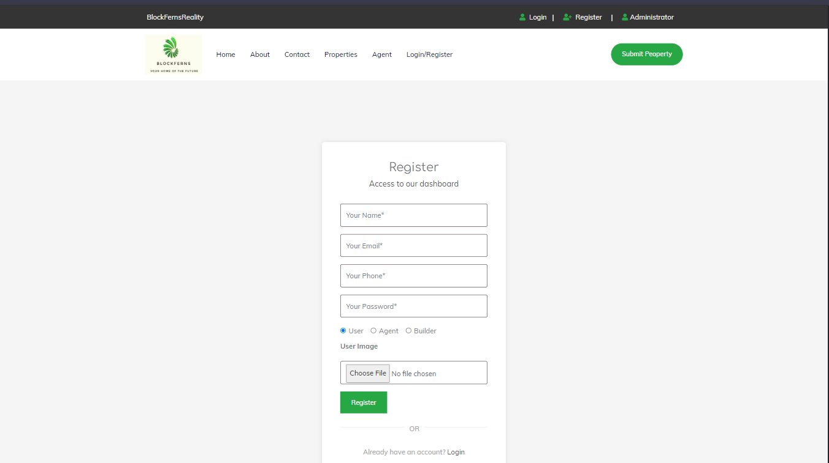

2)Login Page:
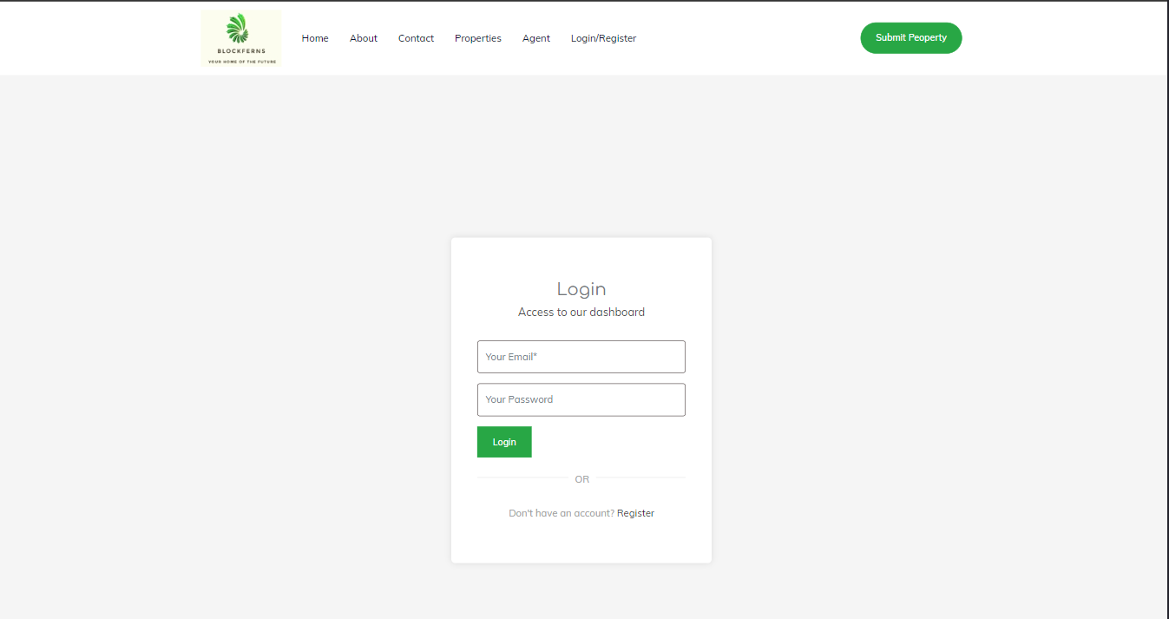

3)Home page:

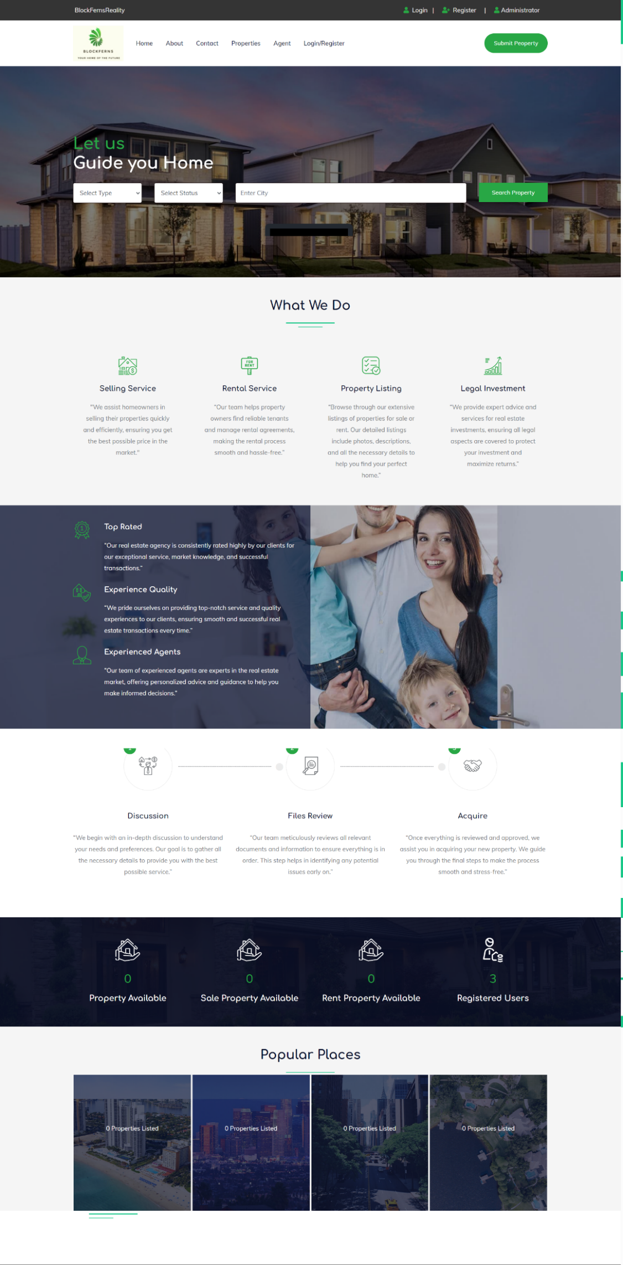

4)contact:

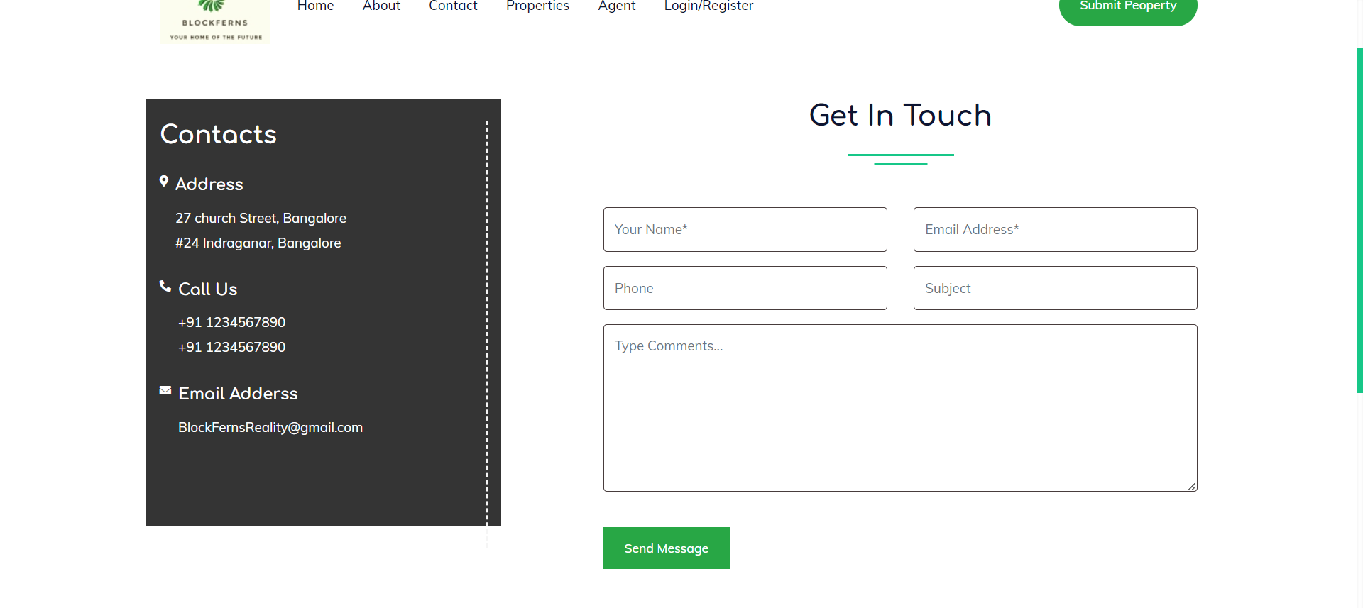
5)properties:

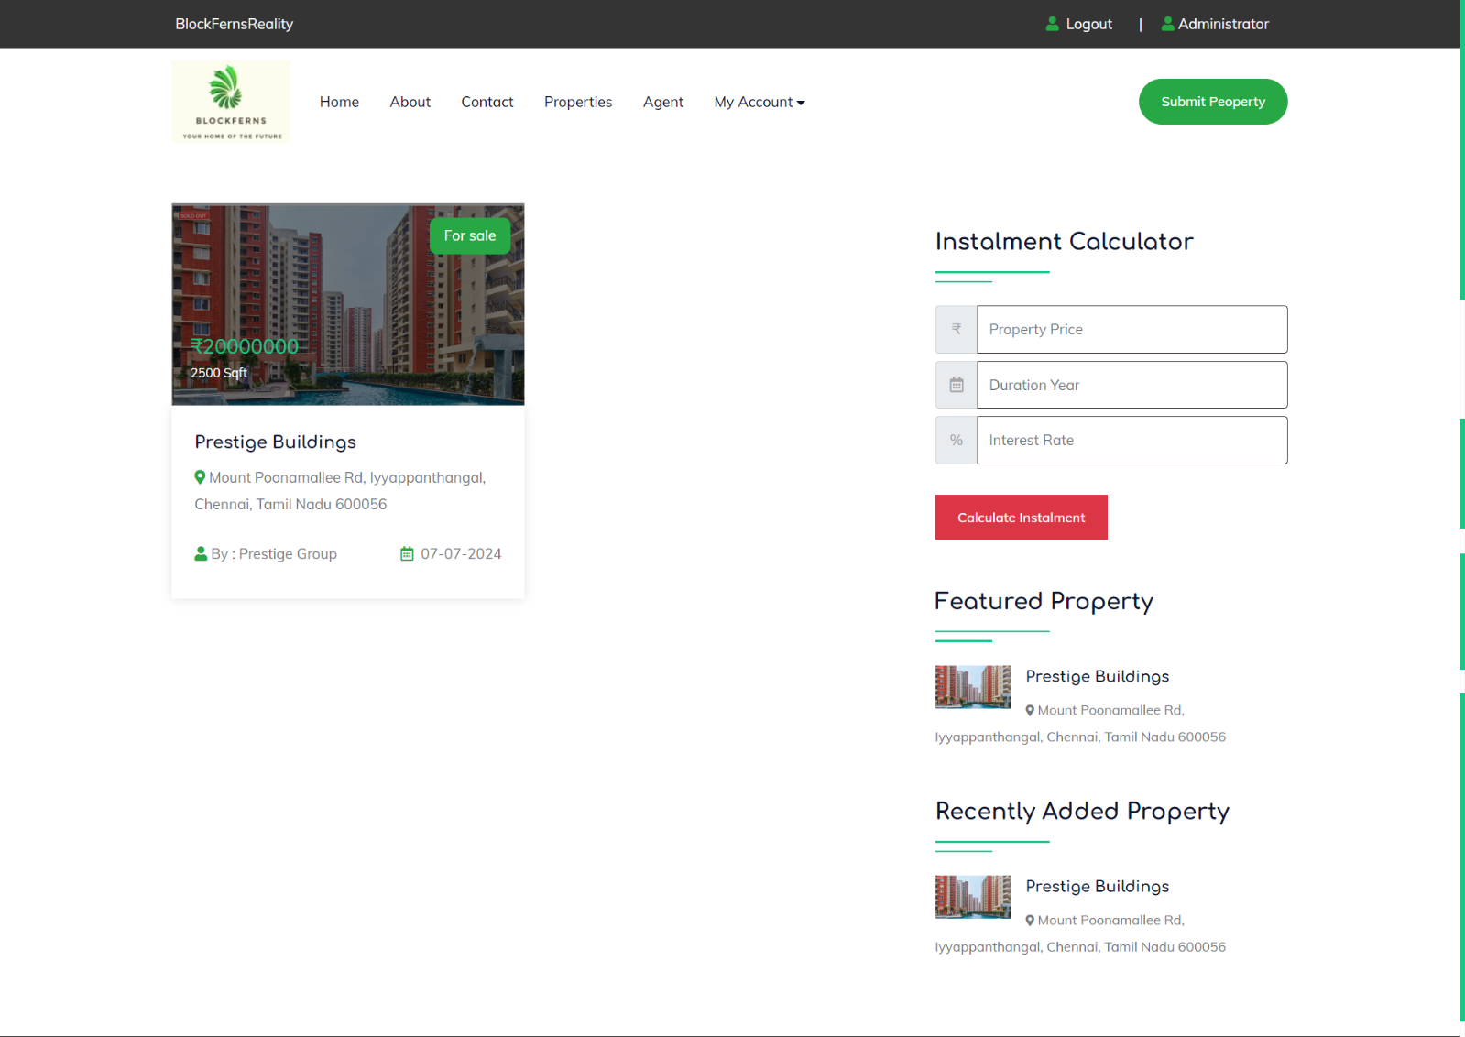

6)Agent:
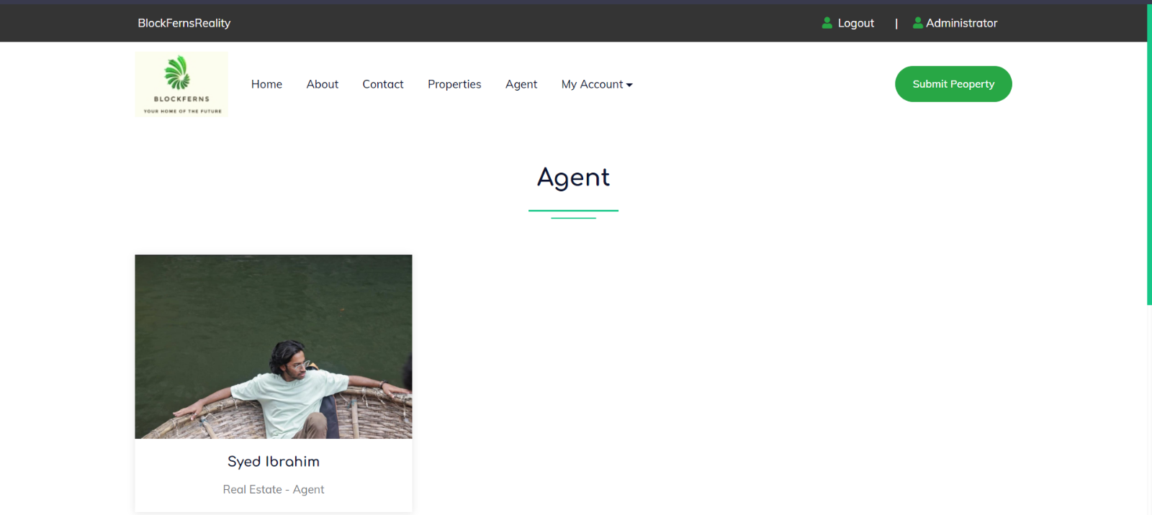

7)Admin Dashboard:
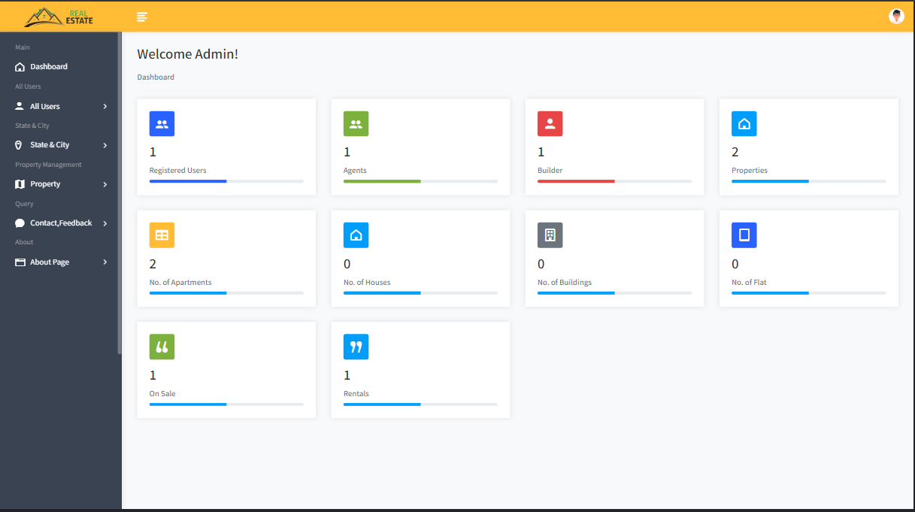

FUTURE ENHANCEMENT

Advanced search filters for price, property type, and amenities, along with an autocomplete search bar, will make finding properties easier. A responsive design update and interactive maps will enhance the user interface, making it more engaging and modern across all devices. Enhancing the loan calculator to support various loan types and providing market trends and analytics will offer users comprehensive tools for better decision-making. These enhancements aim to significantly improve functionality, security, and overall user experience. Ensure the system is fully responsive and optimized for mobile devices to cater to the growing mobile user base.
Additionally, enhancing the feedback feature to allow users to send detailed feedback to the admin will help improve service quality and user satisfaction. These enhancements will collectively boost functionality, security, user engagement, and satisfaction, positioning the application as a leading tool in the real estate market.

CONCLUSION

BlockFernsReality project, a Real Estate Management System developed in PHP with a MySQL database, is a comprehensive web application that provides a platform for buyers, sellers, and agents to interact and manage properties efficiently. The system allows users to view and publish properties, search for properties by state, and manage their posted properties. It also features an instalment calculator, a dashboard for administrators to manage users, states, cities, properties, and feedback, and a testimonial system. The project's user-friendly interface, built using Bootstrap and Vanilla CSS, provides a seamless user experience. The primary objective of the BlockFernsReality project is to design and develop a comprehensive Real Estate Management System that provides an efficient and user-friendly platform for buyers, sellers, and agents to interact and manage properties. The system aims to simplify the process of buying, selling, and renting properties by providing a centralized platform for property listings, searches, and transactions.

BIBLIOGRAPHY

- https://www.w3schools.com/
- https://www.mysql.com/
- https://www.php.net/
- https://developer.mozilla.org/en-US/docs/Web/JavaScript
- https://www.apachefriends.org/
- https://getbootstrap.com/
- https://www.geeksforgeeks.org/javascript/

